TITLE: [PR-CM] Development Application DA10/0222.26 for an Amendment to Development Consent DA10/0222 for Casuarina Town Centre Including 56 Lot Subdivision, Road Works, Infrastructure Works and Landscaping (Department of Planning Application MP06_0258) MOD 10 at Lot 15 DP 1198266 & Lot 13 DP 1014470 Casuarina Way, Casuarina

SUBMITTED BY: Development Assessment and Compliance

Making decisions with you
We're in this together

LINKAGE TO INTEGRATED PLANNING AND REPORTING FRAMEWORK:
² | ^{Making decisions with you}
^{2.1} | ^{Built Environment}
^{2.1.2} | Development Assessment - To assess development applications lodged with Council to achieve quality land use outcomes and to assist people to understand the development process.

ROLE: Provider

SUMMARY OF REPORT:
This report has been prepared to provide Council with technical advice to inform a Council submission in relation to the proposed modifications to the approved Concept Approval and Project Approval for the Casuarina Town Centre development (MP06_0258).
A modification application (Section 75W) was lodged with NSW Department of Planning & Environment to modify the Concept Plan and Project Approval for MP06_0258 in early 2016. This was placed on exhibition and a number of issues were raised with the revised proposal by Tweed Shire Council officers and members of the public who provided submissions to NSW Department of Planning & Environment.

Subsequent to this the proponent has worked with Council since April 2016 to address the issues raised with respect to the initial design and have amended elements of the proposal from that previously submitted.

Issues raised with the original MOD 10 application included (but were not limited to); stormwater management, the extent of earthworks & retaining walls and removal of a 20m landscape buffer to north boundary.

The proponent has now formally submitted a Response to Submissions (RtS) to NSW Department of Planning & Environment. The Department placed the Response to Submissions on public exhibition by way of notifying persons who previously made submissions between Friday 17 November 2017 and Friday 1 December 2017. Council have also been invited to comment on the modification request. The staff comments are being reported to Council for endorsement, which will then to be submitted formally to the Department for consideration.

The application seeks approval to:
- modify the approved lot layout by replacing medium density lots with single dwellings lots. This would:
  - Increase the total number of lots on the site from 97 to 178;
  - Reduce the total number of dwellings across the site from approximately 663 to 447
- modify the built form controls to increase the height of buildings permitted along Grand Parade;
- delete the approved hotel use;
- revise the drainage concept to facilitate the filling of an existing drainage swale and its conversion to a ‘green buffer’;
- change the timing for the provision of additional beach access;
- change the approved staging plan; and
- administrative changes to the conditions of approval in response to the above changes.

Key amendments proposed in RtS include:
- relocation of the local road outside the 20 metre green buffer to the northern boundary; and
- an increase in lots in Stage 1E from 92 lots to 93 lots.

While there are certain elements of the revised proposal which will require further information/clarification through the detailed design phase of development, it is considered that the updated application is worthy of support, subject to amended conditions.

Council staff have recently met with a local resident representative relating to this Modification 10 application, who raised concerns with respect to building height, surf lifesaving storage, open space provision and the Grand Parade (East-west linkage). These are discussed briefly below;

Building Height:
The subject application is for subdivision only, with no buildings proposed at this time. However, the amended masterplan would enable the development of 4 storey development on three of the proposed allotments, with the remainder having a maximum 3 storey height. Future Development applications for development on these allotments would be assessed with respect to height/scale and built form. The site is currently subject to the 13.6m Building Height Control, and the proposed building heights would conform with this control. Therefore no objection is raised on this basis.

Space for Surf Lifesaving Storage,
The provision of surf lifesaving facilities are to be located within the icon building, adjacent to the coastal foreshore. It is noted that existing condition C5 of the Concept Approval states that ‘The future application for development of Lot 17 Is to include details of the surf lifesaving facilities to be provided in the icon building. The application shall include written agreement to the proposed facilities from Surf Lifesaving Australia.’ This is considered to adequately address this matter.

Public Open Space
Concerns were raised with respect to the amount of public open space provided within the development. In this regard it is noted that this isn't a new subdivision and therefore isn't subject to Council’s current controls relating to public open space. From an officer perspective, it is considered that being able to utilise area previously approved for stormwater basins and conveyance (both on the public reserve and to the norther buffer) as useable public open space is a good outcome for the community and this development as a whole.

Grand Parade (East-West) Street Design
Concerns were raised regarding the absence of a Plaza within the Grand Parade alignment and possible wind-tunnelling from the coast arising from this. From Council officer perspective it is noted that the east-west alignment is consistent with that approved under the original Casuarina Town Centre layout and furthermore, the proposed building heights are not considered to result in wind-tunnelling occurring. In any event, there is no provision within Council’s subdivision controls to require the provision of plaza’s within developments.

Draft Plan of Management
The proposed modifications to Casuarina Town Centre include works on Council owned Community Land (Lot 13 DP 1014470) to the coastal foreshore. Concurrent to the MOD 10 application with NSW Planning, a Plan of Management for works on Council land is on exhibition for this site, with submissions being accepted until 20 December 2017. This will be the subject of a further report to Council regarding owners consent.

RECOMMENDATION:
That Council endorses that the attached submission be submitted to NSW Planning & Environment with regard to proposed modifications of the Concept Approval and Project Approval relating to Casuarina Town Centre (MP06_0258) MOD 10.

AMENDED SITE LAYOUT PLAN DA10/0222.26 (MP 06/0258 MOD 10):
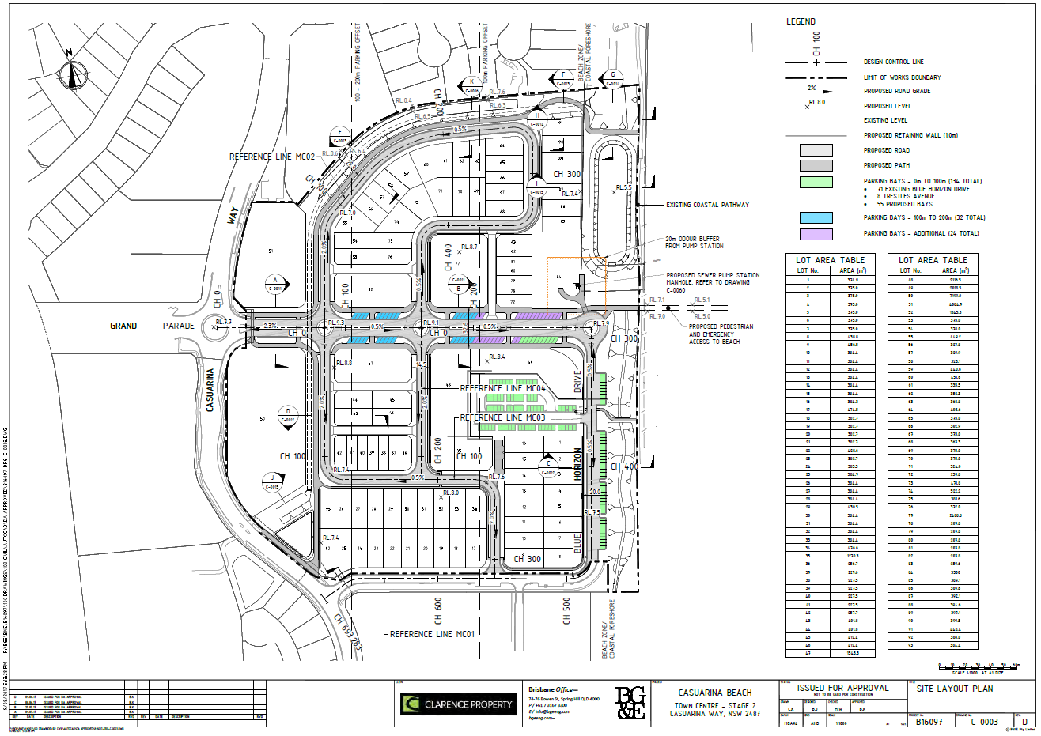

AMENDED DENSITY DIAGRAM DA10/0222.26 (MP 06/0258 MOD 10):
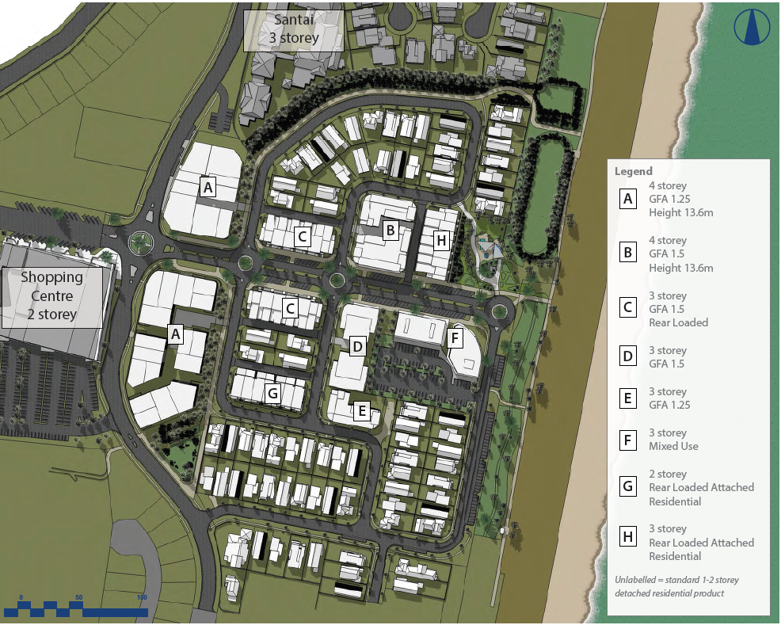

AMENDED BULK EARTHWORKS DA10/0222.26 (MP 06/0258 MOD 10):
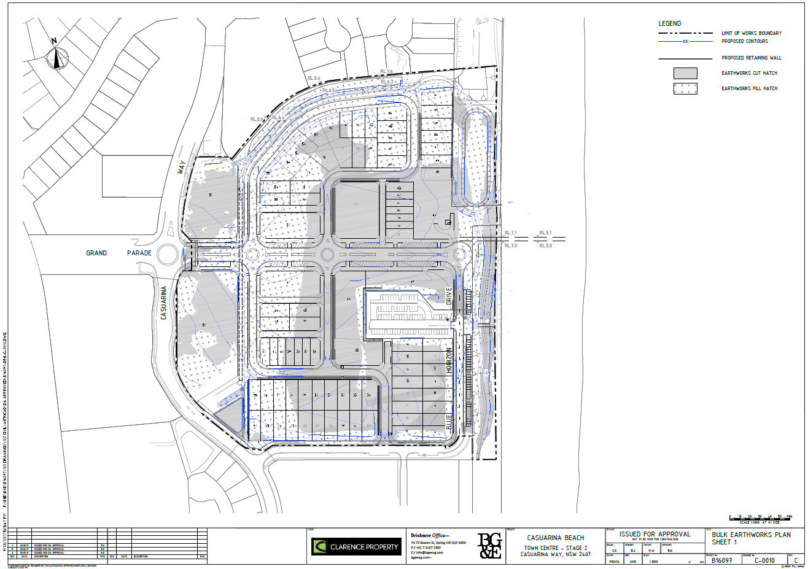
AMENDED LANDSCAPE MASTERPLAN LAYOUT DA10/0222.26 (MP 06/0258 MOD 10):

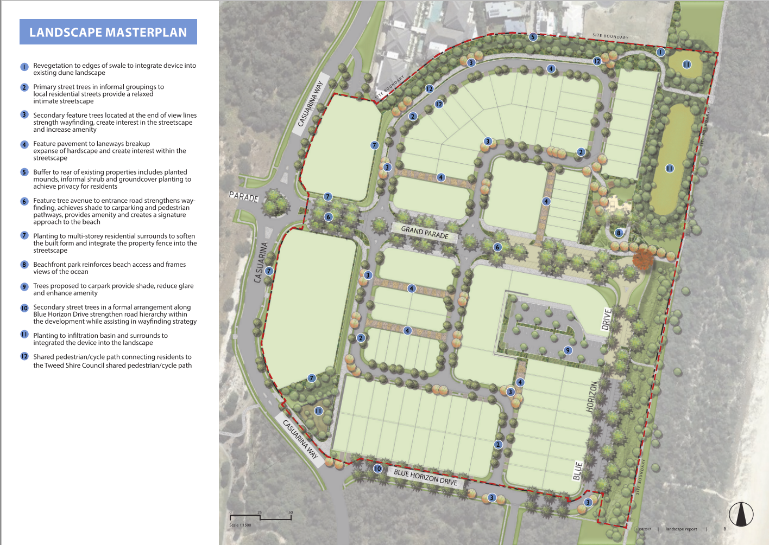

REPORT:
Applicant: Clarence Property Corporation Limited
Owner: Clarence Property Corporation Limited & Tweed Shire Council
Location: Lot 15 DP 1198266 Casuarina Way, Casuarina
Lot 13 DP 1014470 Casuarina Way, Casuarina

Background
Approval was granted on 20 September 2009 by the Minister for Planning to the Concept Plan and Project Application for the Casuarina Town Centre (Major Project 06_0258).

The Concept Plan approval was granted for:

- The subdivision of land in 61 lots including low and medium density residential, retail, commercial and mixed use lots;
- Construction of a retail centre comprising a supermarket, restaurants and shops;
- Construction of a hotel;
- Construction of the associated road network and car parking;
- Construction of all necessary services; and
- Landscaping and open space.

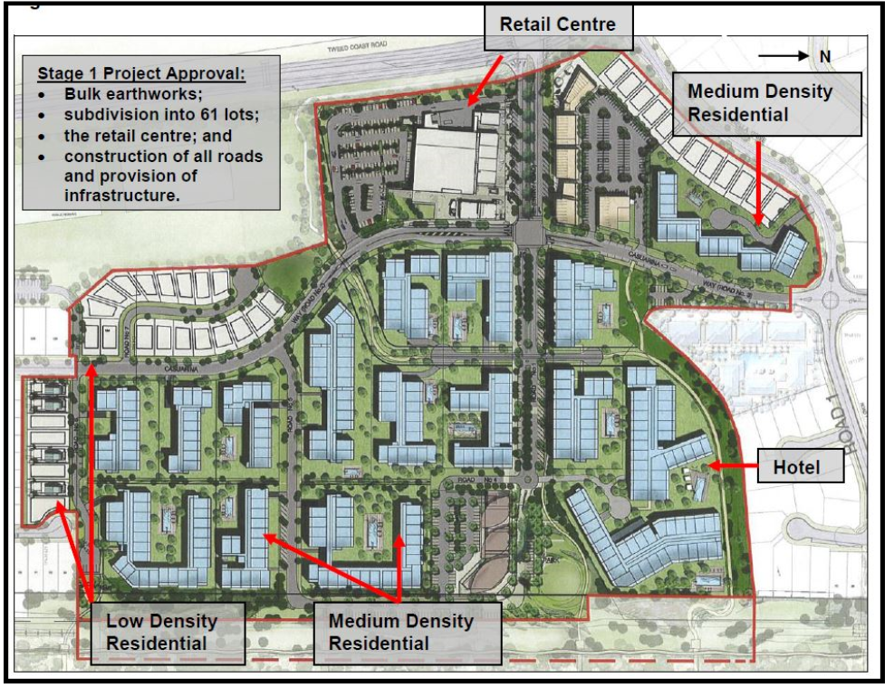
Figure 1: Approved Casuarina Town Centre Concept Plan (Original)

Separately, Stage 1 Project Approval was granted for:

- The subdivision of land into 61 lots;
- Construction of a retail centre comprising 2500m² supermarket, 1160m² of retail shops/restaurants, office space and car parking;
- Bulk earthworks and vegetation clearing;
- Construction of all roads;
- Closure of Dianella Drive;
- Provision of infrastructure and services; and
- Landscaping.

Modifications to these approvals have been subsequently approved on a number of occasions (see details in history below).

In early 2016, a Section 75W modification application (MOD 10) was lodged with NSW Department of Planning & Environment to further modify the Concept Plan and Project Approval for MP06_0258. This included:

- Modification of the approved lot layout and increase in the number of lots permitted on-site from 97 to 177;
- Modification of the built form controls to increase the height of buildings permitted along Grand Parade;
- Deletion of the approved hotel use;
- Revisions to the drainage concept to facilitate the filling of the existing drainage swale and the conversion of the swale to a 'green buffer';
- Changes to the timing for the provision of additional beach access;
- Changes to the approved staging plan; and
- Administrative changes to the conditions of approval in response to the above changes.

The Department placed the modification on public exhibition between Wednesday 24 February 2016 and Tuesday 29 March 2016.

Tweed Shire Council provided a submission (endorsed by elected Council) to this MOD 10 application in April 2016. Concerns were raised with respect to various aspects of the proposal, including stormwater drainage to the north boundary, reduction of ‘green buffer’ between Casuarina Town Centre and residents to the north, the extent and location of retaining walls proposed, useability of public land, road layout and owners consent for development on Council owned Community land.

Subsequent to Council’s submission to NSW Planning extensive consultation has occurred between the proponent and Council over the past 18 months in an attempt to overcome the previously identified areas of concern. The resulting earthworks and stormwater solutions are considered a vast improvement on the previous design.

This enables Council officers to support the exhibition of a Plan of Management which would formalise the works in Council Community Land. This Plan of Management is currently on exhibition. Furthermore, the proponent has submitted updated information by way of a Response to Submissions (RtS) to NSW Planning for consideration.

This RtS has been notified to previous submitters, including Tweed Shire Council for comment. This report is an assessment of the amended proposal and, if endorsed by elected Council, will consist of the Tweed Shire Council submission to NSW Planning on the Casuarina Town Centre MOD 10 application. To this end, NSW Planning have advised the follwoning in notifying the updated application;

The Clarence Property Corporation has submitted a response to submissions (RtS) for the modification of the Casuarina Town Centre in the Tweed Shire Local Government Area.

The application seeks approval to:
- modify the approved lot layout by replacing medium density lots with single dwellings lots. This would:
  - Increase the total number of lots on the site from 97 to 178;
  - Reduce the total number of dwellings across the site from approximately 663 to 447
- modify the built form controls to increase the height of buildings permitted along Grand Parade;
- delete the approved hotel use;
- revise the drainage concept to facilitate the filling of an existing drainage swale and its conversion to a ‘green buffer’;
- change the timing for the provision of additional beach access;
- change the approved staging plan; and
- administrative changes to the conditions of approval in response to the above changes.

Key amendments proposed in RtS include:
- relocation of the local road outside the 20 metre green buffer to the northern boundary; and
- an increase in lots in Stage 1E from 92 lots to 93 lots.

The above matters are assessed in this report. The RtS has been reviewed by Council’s Development Assessment, Water & Wastewater, Development Engineering, Environmental Health, Natural Resource Management and Recreation Services Units. Furthermore, the proposal has been reviewed by Council’s Infrastructure Engineers who have provided comment with respect to stormwater management, and traffic/road layout.

Site
The Casuarina Town Centre development was originally approved over a 26.2ha land area, identified in Figure 1 above. The site is located adjacent to the Casuarina Beach foreshore and has been partially developed since the original Concept and Project Approvals were issued in 2009.

This modification was originally submitted over an 8.93ha portion of the development, located to the north-east corner of the original site. This would correlate with Lot 15 DP 1198266, for which landowners consent has been submitted to the Department of Planning and Environment. However it was noted through assessment of the MOD 10 submitted information that the modified layout (reproduced under figures 2 & 3 below) also includes Lot 13 DP 1014470, a 5.2 ha Tweed Shire Council owned parcel of land located adjacent to the coastal foreshore.

A Plan of Management is currently on exhibition to enable the proposed works within this land.

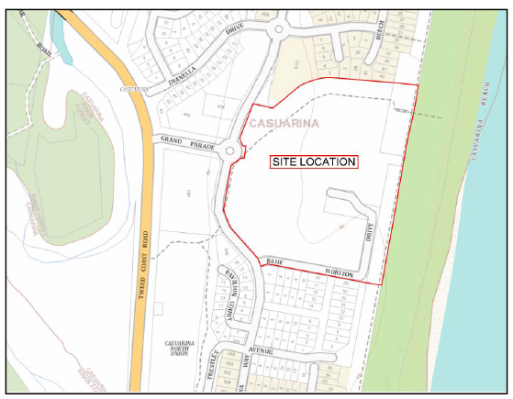
Figure 2: Area of Proposed Development

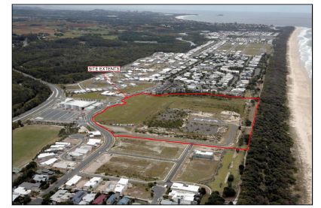
Figure 3: Aerial Imagery of Site

History
As outlined elsewhere in this report, Concept Plan and Stage 1 Project Approval was originally granted on 20 September 2009. The Concept Plan approval was granted for:

- The subdivision of land in 61 lots including low and medium density residential, retail, commercial and mixed use lots;
- Construction of a retail centre comprising a supermarket, restaurants and shops;
- Construction of a hotel;
- Construction of the associated road network and car parking;
- Construction of all necessary services; and
- Landscaping and open space.

Stage 1 Project Approval was granted for:

- The subdivision of land into 61 lots;
- Construction of a retail centre comprising 2500m² supermarket, 1160m² of retail shops/restaurants, office space and car parking;
- Bulk earthworks and vegetation clearing;
- Construction of all roads;
- Closure of Dianella Drive;
- Provision of infrastructure and services; and
- Landscaping.

Subsequent to this, there have been (to date) nine modification applications to these approvals, as detailed below;

Mod 1 (Approved 17 June 2010) - Modifications include filling the existing drainage easement running through the site, and works to include piping of stormwater drainage through the former easement channel. Modifications also include carrying out of stormwater infiltration and landscaping works within Lots 10 and 13, including extensions to the existing cycleway network and upgrades to public open space areas. These modifications were a result of Tweed Shire Council granting the proponent owners consent to undertake stormwater, sewerage and landscape works in Council owned land as it was initially withheld.

Mod 2 (Approved 1 July 2011) – Modifications involve the carrying out of approved Stage 1 throughout two separate stages (Stage 1A and then the balance of Stage 1). The modified staging regime was sought to provide a more logical sequence of services, including road connectivity; drainage and car parking; relocation of the swale; and, the provision of cycleway and pedestrian linkages.

Mod 3 (Approved 7 March 2012)-
This modification involved the following:
- A reduction in the size of the approved supermarket building and floor space by 200m²,
- Reduction of the height and bulk of the supermarket building,
- A total reduction of floor space from 4,301m² to 3,705m²,
- A relocation of the approved first floor office space,
- Replacement of an approved restaurant tenancy with a retail shop,
- Removal of basement car parking and provision of additional at-grade car parking resulting in an overall reduction of 14 spaces,
- Adjustment of the loading dock, and
- Increased landscaping and signage.

Mod 4 (Approved 24 April 2014)
This application relates to modification to the staging of the subdivision, consolidation of lots 7, 8, 9, 14 & 15 into a development lot, modification of the approval to allow the sequencing for future stages to be varied with the written approval of the Department, modification of the timing to obtain approval for the beach access and an amendment to the timing in which Section 94 and Section 64 Contributions are paid for the shopping centre.

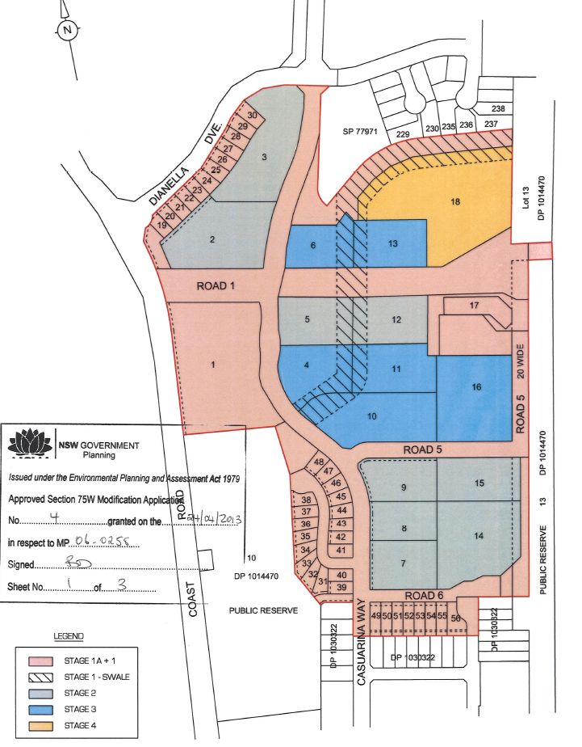
Figure 4: Mod 4 Concept Staging Plan

Mod 5 (Approved 24 September 2013)
Modification 5 approved an amendment to the location of a retaining wall on the south east boundary of the Casuarina Town Centre site adjacent to the cul-de-sac of Road 6.

Mod 6 (Approved 16 May 2014)
Modification to the Concept Plan and Stage 1 Project Application for the Casuarina Town Centre involving:
- change of use of Lots 7,8 ,9, 14 &15 from medium density residential to low density residential (single-dwelling use);
- 40 lot Torrens title subdivision of adjoining Lots 7, 8, 9, 14 & 15 with associated civil works;
- the introduction of additional Stages 1B and 1C;
- a two-lot subdivision of commercial Lot 2; and
- a request to allow for small lot housing within the town centre site.

The 40 lot subdivision layout approved under this Mod is located to the south of the area subject to this application and is demonstrated under Figure 4 below;

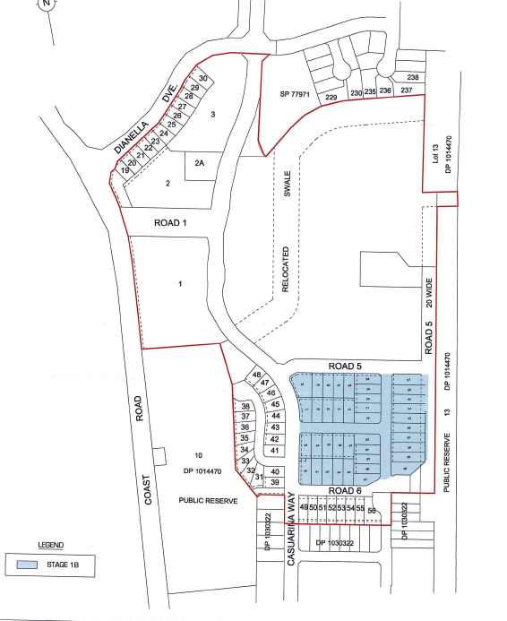
Figure 5: Mod 6 Approved 40 lot subdivision

Mod 7 (Approved 18 June 2014)
Modification to the retail centre approved as part of the Stage 1 Project Application for the Casuarina Town Centre. The modification involved:
- a 1,000sqm increase in gross floor area of the supermarket;
- a 581sqm increase in gross floor area of specialty retail;
- amended car parking arrangements within the retail centre; and
- amendments to section 94 contributions.

Mod 8 (Approved 21 January 2015)
Modification to Project Approval including design changes to the retail shopping centre comprising an amended roof design and new design and finishes to all facades. A new 12m high pylon sign was also approved to the north-west corner of the shopping centre site.

Mod 9 (Approved 15 June 2015)
Further modification to Project Approval including design changes to the retail shopping centre as a consequence of the detailed design process and tenant requirements.

Mod 11 (Approved 24 April 2017)
Modification to Project Approval hours of operation at Coles Supermarket.

Previous Council Reports
This is the third report which has been brought to Council on MOD 10 to MP06_0258 in regard to the Casuarina Town Centre (Council Reference DA10/0222.26). The first report was from 21 April 2016 in which concerns were raised with various elements of the proposed modifications (see attachment). Since this time the applicant has responded to Council’s concerns and has invested a significant amount of time and resources into amending the proposal to address the matters raised.

The second report was brought to Council on 21 September 2017, where Council resolved to place a draft Plan of Management for LOT 13 DP 1014470 on public exhibition (see attachment). This was required to enable the Casuarina Town Centre layout to be consistent with works on adjoining Council land.

Assessment of Modifications Proposed as Part of this Application

NSW Planning notification documentation identifies that the following amendments are proposed through the MOD 10 and Response to Submissions;

The application seeks approval to:
- modify the approved lot layout by replacing medium density lots with single dwellings lots. This would:
  - Increase the total number of lots on the site from 97 to 178;
  - Reduce the total number of dwellings across the site from approximately 663 to 447
- modify the built form controls to increase the height of buildings permitted along Grand Parade;
- delete the approved hotel use;
- revise the drainage concept to facilitate the filling of an existing drainage swale and its conversion to a ‘green buffer’;
- change the timing for the provision of additional beach access;
- change the approved staging plan; and
- administrative changes to the conditions of approval in response to the above changes.

Key amendments proposed in RtS include:
- relocation of the local road outside the 20 metre green buffer to the northern boundary; and
- an increase in lots in Stage 1E from 92 lots to 93 lots.

These proposed amendments are reviewed in detail below;

Modify the approved lot layout by replacing medium density lots with single dwellings lots. This would:
  - Increase the total number of lots on the site from 97 to 178;
  - Reduce the total number of dwellings across the site from approximately 663 to 447

The revised subdivision layout is demonstrated in Figures 6-8 below and is reviewed with respect to earthworks, road layout, public open space and density;

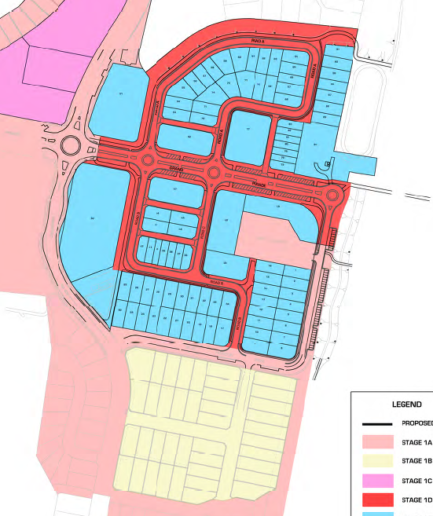
Figure 6: Proposed Allotment Layout

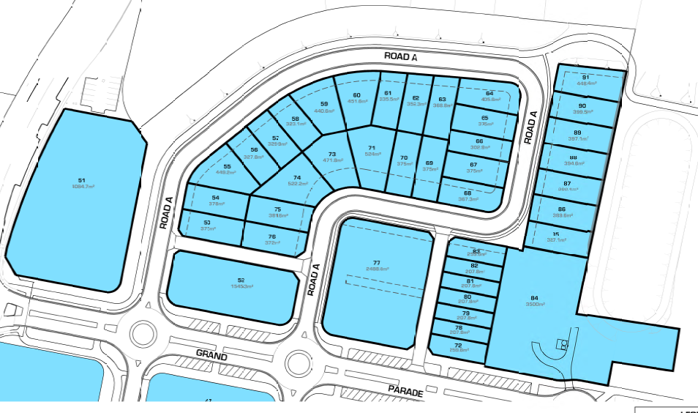
Figure 7: Proposed Layout (North)

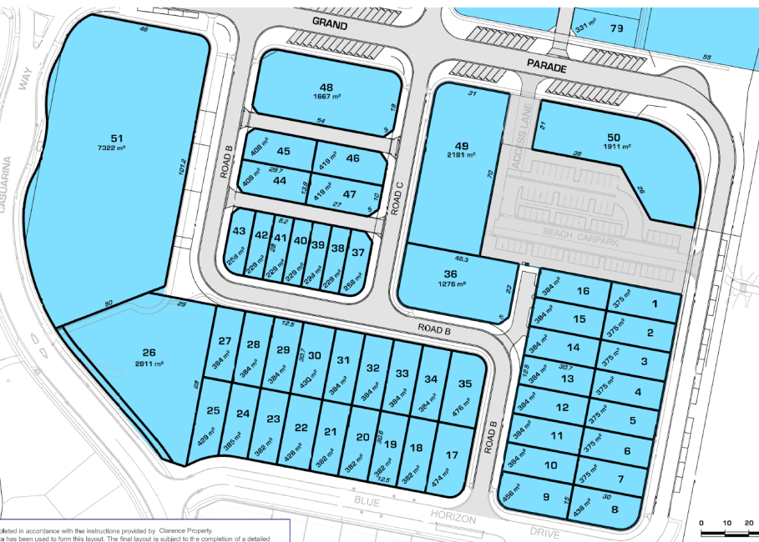
Figure 8: Proposed Layout (South)

Earthworks/Retaining walls
Concerns were previously raised with respect to the extent (height) and number of retaining walls proposed under the previous MOD 10 layout. In particular it was noted that retaining walls up to 4m high were proposed. Concerns were was also raised with respect to the use of retaining walls on public road reserves/open space foreshore area on the eastern boundary. These walls would attract increased Council maintenance issues such as graffiti, re-painting, weed control etc. compared to a gradient batter that is grassed.

The proponent has revised the subdivision design, limiting the overall extent of retaining walls to three over the site and limiting these in height to a maximum of 1m.

Council’s Development Engineering Unit has advised the following with respect to this;

‘An updated earthworks / land forming engineering plan has now been provided by BG&G which ultimately reduces the number of retaining walls across the site to a total of three (3). All the proposed retaining walls are proposed to be a maximum of 1m in height; hence the previous retaining wall of 4m has been removed. All proposed retaining walls are now within private property and comply with Tweed Shire Councils Development Design Specification – D6 Site Regrading (TSC-D6) specifies that the maximum permissible combined of retaining walls or batters in residential subdivisions. The proposed earthworks and retaining walls are now accepted.’

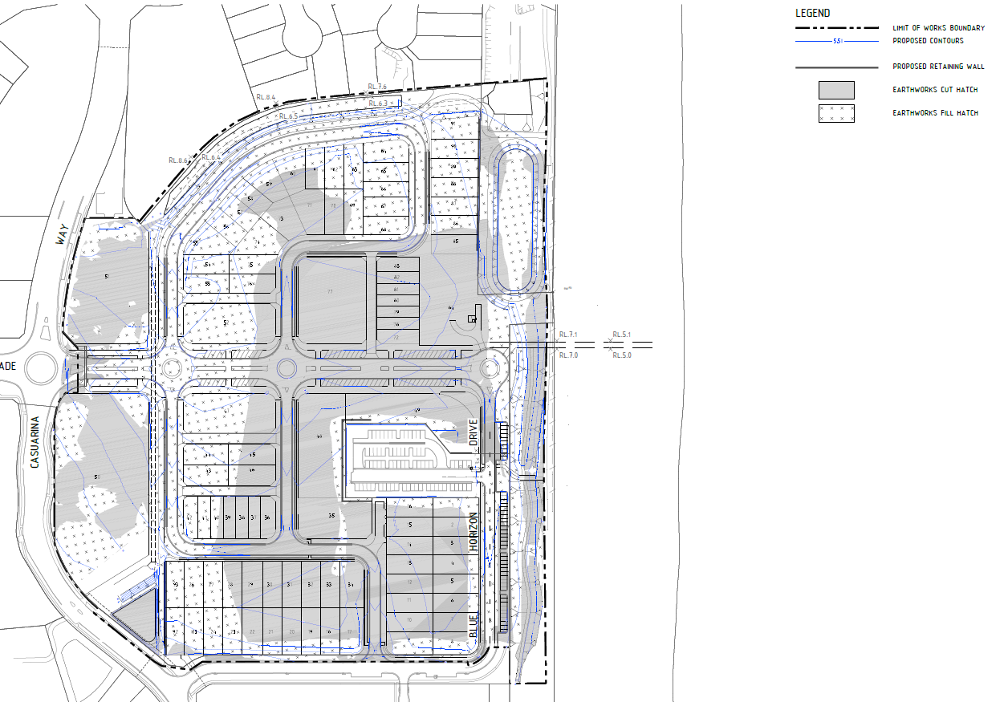
Figure 9: Bulk Earthworks Plan

Further to this, it is noted that there was previous concerns raised in relation to earthworks proposed to the north east of the site, including on Council land in this area, with retaining walls of approximately 2.5m anticipated by Council staff. This raised issue with the maintenance of this area (including access) and also the useability of any of the space.
The amendments to the extent of earthworks proposed has reduced the level changes to this area generally. In reviewing this Council’s Manager Roads & Stormwater has advised that “…significant stormwater drainage infrastructure was proposed within the coastal reserve along the eastern frontage of the town centre site. Initially this consumed a large area, required levels that resulted in unsuitably high retaining structures on public land, and was judged by Council officers to be a poor outcome for the public reserve. Through a process of meetings and emailed correspondence, the applicant’s engineering consultants modified the landform and stormwater interface to produce a basin design that is now suitable to Council officers and accepted by the developer.’

A typical cross section of levels in this area is provided below;
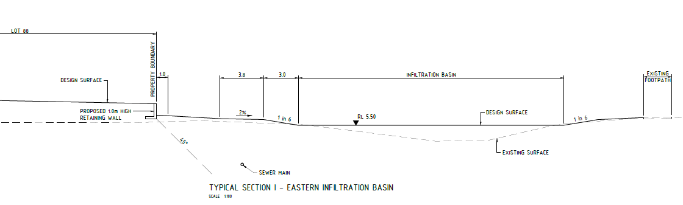
Figure 10: Stormwater Cross-Section Plan

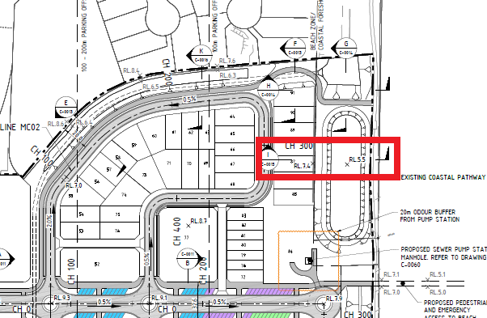
Figure 10A: Stormwater Cross-Section Plan

Earthworks now proposed are considered to be acceptable by Council officers.

Road Layout

The proposed modification incorporates a new road layout to service the proposed allotments. This has been reviewed by Council’s Traffic Engineer and Development Engineering Unit who have provided comment with respect to traffic and public car parking. It is noted that roundabouts have now been provided to the Grand Parade intersections and public parking modified in response to Council’s Traffic Engineer comments on MOD 10.

Further comment has been provided with respect to road network and parking by Council’s Traffic Engineer and Development Engineering Unit as per the below, which is requested to be taken into account by NSW Planning;

Traffic Engineer Comments
Generally the traffic facilities are considered appropriate. It is noted that the stub road connection between Grand Parade and Road A (See figure 11 below) may result in undesirable movements such as u-turns on Grand Parade to access angled parking bays. Given the close proximity of roundabouts on Grand Parade it is recommended that the centre median be extended on Grand Parade thereby limiting access to the connection to left in and left out only.

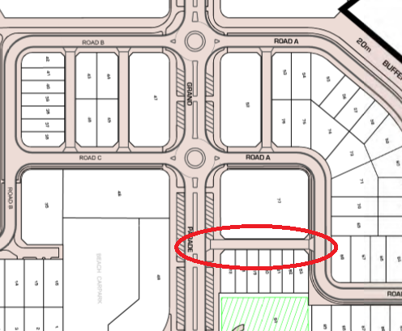
Figure 11: Road connection between Road A & Grand Parade

Development Engineering Unit
Council previously requested further information with respect to the four rear access laneways (which now serve lots 72 & 77– 83, 36-47 and 52, 53 & 76). Specifically it was queried whether these would be privately owned with easements or public roads conforming to Council standards. From the updated plans submitted, it appears that these are to be dedicated to Council as road reserve however for Council to accept these they would need to be demonstrated to Council standards.

Furthermore the access driveway servicing proposed Lots 14, 15 and 16 is indicated as being public road reserve. Again, this is required to be demonstrated to be to Council standards if it is to be dedicated as road reserve, otherwise the application should be modified to demonstrate this as privately owned right of carriageway etc.

Water/Sewer Infrastructure
Background
Extensive consultation has been undertaken between Council and the proponent with respect to the provision of water/sewer services subsequent to MOD 10 being submitted for consideration. Through this, Council have now accepted in principal concept design of a sewer pumping station (SPS) within the proposed park area.

The main areas of concern with the proposed SPS was the buffer zone provided and the depth of the well. Agreement in principal was given to the concept plans provided by the applicant to Council once they met the minimum buffer zone requirement of 30m and the wet well depth requirement of 6 metres.

Sewer
The Water & Wastewater Engineering plans provided within the RtS provided to the Deparment of Planning and Environment are dated 09/08/17. These plans include reference to a 20 meter buffer zone from the proposed SPS. However prior to the submission of these plans, agreement was made with the proponent that they would provide a 30 meter buffer. Furthermore, when the plans are scaled, the orange area shown on the plan appears to be a distance of 30 meters (see figure 12 below). Council will require a minimum of 30 meters despite what is indicated on this plan.

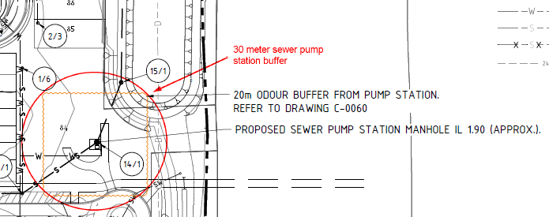
Figure 12: Buffer Distance from Sewer Pump Station

Council officers also have concern with the lack of detail provided to date regarding the sewerage pumping station. The design provided shows only a manhole where the wet well will be located at a depth of just under 6 meters. However this design does not take into account any of the SPS design requirements and Council have concerns that the proposed wet well will not meet Council development design specifications outlined in D12.20.5(b) that pump wells shall be a maximum depth of 6.0 m (top slab to pump well floor). Council has indicated it may accept slightly more than 6 meters, however should they not be able to meet this requirement, the design will require amendment to meet the specifications. This may include, a redesign of the upstream incoming sewer invert levels, increasing the upstream pipe size to amend the minimum grade requirements, reducing the design surface level at the location of the wet well to reduce the depth, or another option nominated by the deisgner that meets wet well depth requirements.

The proposed SPS for this site was intially discussed as a lift station. However with the exception of the lack of a rising main at this station, this SPS will operate as a pumping station and not a lift station, because in principle, a lift station should be able to operate even when the pumps are not on, by means of filling the well and overflowing to the next catchment. However due to the fill proposed on the Casuarina Town Centre lot, the ground level upstream of the development is significantly lower (by approximately 3 meters or more). Therefore, should the SPS well fill, the overflow would occur upstream of the well. Therefore, for all intensive purposes, this SPS will be known as a pump station (not a lift station). Furthermore, sufficient storage will need to be provided by the developer at the SPS (to 8 x ADWF as outlined in the D12) to ensure that if the pumps are not operational, there is sufficient storage to prevent upstream overflows.

Other details that are yet to be provided and will need to be shown in the detail design of the sewer include:
- Sewers to be located in road reserves where commercial lots are proposed.
- Proposed sewer connection for lot 50 to be confirmed to ensure it meets Councils requirements that maintenance holes should be limited to 5.0m deep.
- Additional manholes required where sewer is at road crossing (ie: from Class 8 to Class 12 under road)
- Sewerage Study to be provided as part of detail design.
- SPS design to be provided as part of detail design.
- MOD 10, if approved would need to be conditioned to ensure that it is clear that any plans provided to date are considered as conceptual only and detail design will be required prior to construction certificate for approval by Council.

Furthermore, during construction of proposed stage 1D, Council will require the exising live sewer within the lot to remain accessable for repairs and maintenance until it is decommissioned. Therefore Council will require that bulk earthworks within a 10 metre proximity to the existing trunk sewer on the lot shall not commence until the provision of the new sewer pumping station and trunk sewer main has been completed and commissioned as part of the initial staged works and approved by Council. Similarly the demolition of the existing trunk sewer cannot commence until the provision of the new sewer pumping station and trunk sewer main has been completed, commissioned and approved by Council.

Water
To date a water supply layout has been provided by the proponent, with no information regarding the proposed pipe sizes within the development are shown. Therefore, whilst the Water supply design generally appears to meet Council requirements with respect to layout, the proponent is yet to demonstrate that they will be able to meet Council standards within the development. It will be up to the proponent to demonstrate this within their detail design plans via an hydraulic model or another method that demonstrates that these requirements shall be met.

Other details that are yet to be provided and will need to be shown in the detail design of the water include:
- Water Supply Study to be provided as part of detail design.
- MOD 10, if approved shall be conditioned to ensure that it is clear that any plans provided to date are considered as conceptual only and detail design will be required prior to construction certificate for approval by Council.

Public Open Space

Area dedicated to Council
NSW Planning is requested to identify the overall quantity of open space dedicated to Council under the MOD 10 layout as compared to that previously approved. It is noted that the original assessment undertaken combined the total area of dedicated easement and open space and identified the location and size of these areas (See Figure 18 & Table 2 of Director-General’s Environmental Assessment Report).

While the amount of casual open space being dedicated is considered to be less than that required under Council’s subdivision manual controls based on the population envisaged, it is recognised that this is an application to modify a previous approval and that overall the population is proposed to be reduced through this modification.

Cycleways
Consideration should be given to the connections between proposed cycleways and footpaths within the Casuarina Town Centre development. In particular, it should be ensured that a shared path doesn’t end suddenly at a footpath but instead, where possible should join another cycleway/shared path that leads to a destination point. The following specific comment is provided;

- The cycle path at the South West corner of the Town Centre has been moved on the submitted landscape plans so it doesn’t now go through the open space lot for drainage reserve. Instead, the cyclepath now joins the existing cyclepath at Casuarina Way with a sharp turn. It is noted however that Plan P7 -Dedication & Easement Plan Stages 1D & 1E (prepared by Newton Denny Chapelle) demonstrates a road reserve dedication to this area which generally follows the previous cyclepath (See figure 13 below). NSW Planning are requested to clarify the intended cycleway layout at this location and ensure that any layout approved connects in a safe manner with the Casuarina Way cycleway.
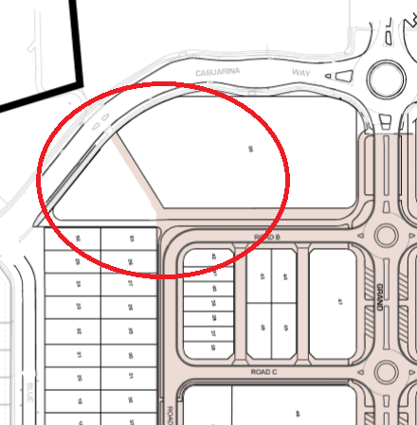
Figure 13: Road reserve (Possible Cycleway)

- At the North East end of the Town Centre there has been a change to where the cyclepath joins Casuarina Way. Previously this was through the north portion of proposed lot 51. NSW Planning is requested to consider whether the deletion of this linkage is appropriate as part of a detailed assessment.

- The cyclepath should be extended to connect to the existing shopping centre.

Public Park (Proposed Lot 84)
The following comments are provided with respect to the public park. It is considered that these relate to detailed design within the park and can likely be dealt with via appropriate conditions of approval, but nevertheless outline important considerations for Council which are requested to be taken into account as part of NSW Planning assessment;

- The park is impacted upon by the infiltration basin, sewer pump station and service driveways being located within the site. In this regard, the detailed design of the park must be carefully considered to ensure that the park can function to a high level.

- The service driveway for the sewer pump station appears excessively long, extending approximately 20m past the location of the pump station. Council wishes to ensure that a link is maintained between the playground and the coastal foreshore.

- The landscape plan for this park should maximise use of adjoining public land, as the land parcel (showing an area of 3500m²) is an awkward shape for a park.

Density of Casuarina Town Centre Development
The proposed modification results in an amended allotment layout design as outlined under figures 6-8 above. It is noted that this amended layout will result in a reduction in density of development on site. The Dwelling Density submitted as part of the RtS outlines the following with respect to this;

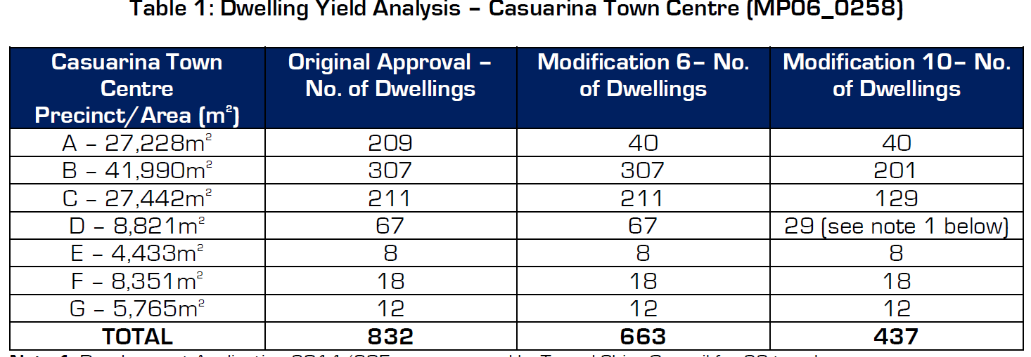

It is noted that under Modification 6 (Approved 16 May 2014) a reduction in density was previously approved to the Casuarina Town Centre development on land to the south of MOD 10 land, where medium density allotments to provide for 208 units was changed to a 40 Torrens title allotment configuration.

This application would further reduce the density of development to the overall Casuarina Town Centre.

At the time of assessment of Mod 6, Council provided the following comments concerning the reduced density of the development over these allotments;

“In assessing the merits of the original proposal it was noted that a variety of low and medium density housing options was an element of the overall Casuarina Town Centre development which provided an environmental, social and economic benefit and resulted in the support of the development. Furthermore, it is considered that a town centre site should have a higher residential density in close proximity to services such as the proposed retail area in order to maintain the viability of such services.

Therefore, from Councils perspective it is considered necessary that any such amendment be suitably investigated from a holistic perspective regarding potential impacts on the Casuarina Town Centre Development.

It is not considered that adequate information has been provided in this regard to determine that the proposed amendment will not have a detrimental impact on the Casuarina Town Centre development as a whole. As such, a detailed assessment of the potential impacts arising from the proposed modification should be provided in order to ascertain the impact of the modification with respect to this.”

The modification application now submitted seeks to further reduce the density of development over this area by an additional 226 dwellings. Tweed Shire Council would again request that Department of Planning & Environment asses this as a reduction to the density of the overall Casuarina Town Centre development and consider its suitability from an holistic perspective regarding potential impacts on the Casuarina Town Centre Development.

It is further noted that under Tweed Local Environmental Plan 2014, a large portion of land to which this application relates is zoned B2 Local Centre and R3 Medium Density Residential uses where a greater residential density would ordinarily be provided.

Modification of the built form to increase the height of buildings permitted along Grand Parade

The submitted application advises that the concept plan has been designed in order to create a gradual increase in density from the surrounding existing residential uses to the town centre. A concept drawing of this has been reproduced under figure 14 below;
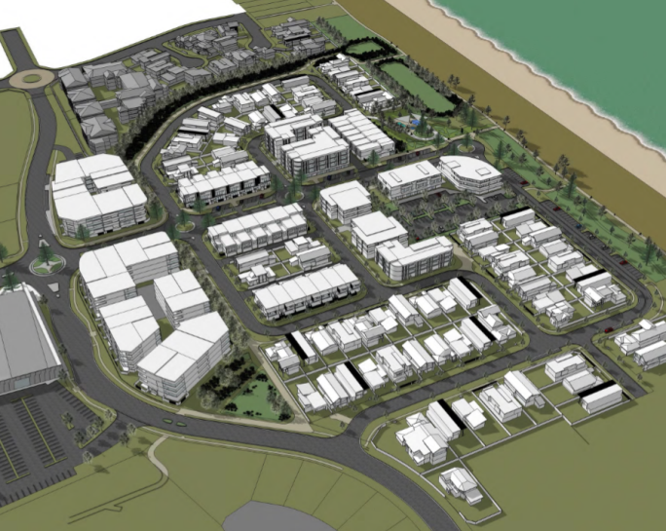 | 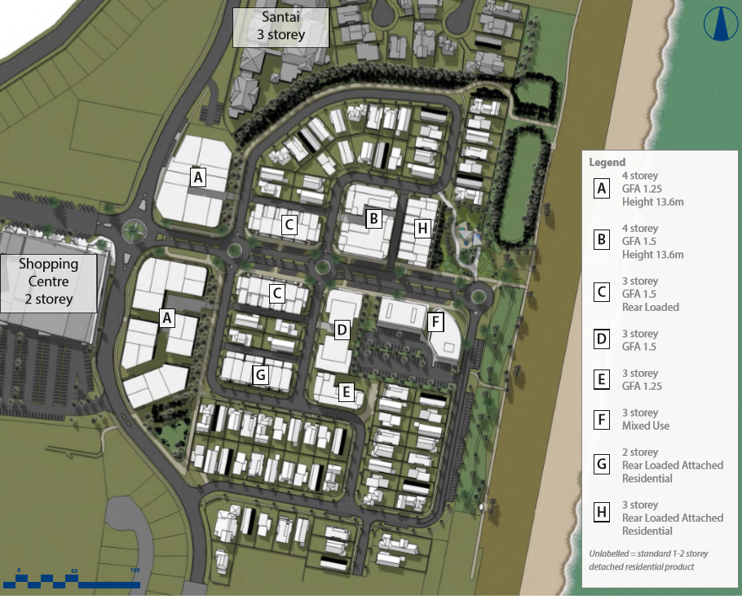
Figure 14: Concept Imagery

It is further noted that the modified master plan encompasses two four storey apartment sites to the western end of Grand Parade and one to the north of Grand Parade. Grand Parade is stated as being lined with three and four storey mixed use retail (ground floor) and residential units (levels 2 & 3). The submitted application advises that the proposed building height accords with the 13.6m building height limit prescribed within the Tweed Local Environmental Plan 2014.

The Grand Parade sheet contained within the Casuarina Beach Town Centre Vision & Landscape Document prepared by RPS (Page 4 of 9) indicates that there would be Ground Level Mixed Use development such as shop top housing and SOHO type units proposed as part of this modification.

Previously, Council provided comment requesting that the land use definition of any such SOHO units be provided in order to determine whether this would entail a commercial use or a home office area which would be ancillary to a residential unit on site.

Council would be supportive of the area being utilised for commercial and mixed use type development, consistent with the current zoning over the land under the Tweed Local Environmental Plan 2014 (B2 Local Centre).

Council officers raise no objection to the proposed modified building heights. In this regard it is noted that this area was previously subject to a three storey building height control under Tweed Local Environment Plan 2000, however the current Council controls under Tweed Local Environmental Plan 2014, a building height of 13.6m is identified for this site, which the applicant states will be complied with.

With respect to the built form gradual increase in height, please see comments above relating to the density being achieved across the Casuarina Town Centre development.

Deletion of the approved hotel use

A tourist hotel was approved as part of the original Casuarina Town Centre development. As part of this S75W modification application, it is proposed to delete this use ‘due to the development not being deemed economically feasible having regard to existing tourist development within the immediate locality.’

Tweed Shire Council does not have any specific comments with respect to the deletion of this use, however the Department of Planning and Environment is requested to determine any impacts associated with same as part of its assessment of the modification.

Revisions to the drainage concept to facilitate the filling of the existing drainage swale and the conversion of the swale to a 'green buffer'

Background
There is currently a 36m swale located to the north site boundary, approved under the original approval. Modification 1 raised the proposal to pipe the swale and reduce the width of drainage land to accommodate it. Under this Modification the Department issued an approval that set various design criteria around the sizing of the piped system to ensure equivalency of performance in extreme storm events, requirements to offset lost infiltration capacity, and requirement that a 20m wide drainage reserve be created over the drainage infrastructure along the northern boundary, thereby preserving a buffer function and continuity for a cycleway between the sports fields to the coastline cycleway.

In granting owner's consent for works to be carried out in this area, Council agreed to relinquish the 36m wide easement in return for the dedication of the 20m wide drainage reserve. To date these works and dedication have not taken place. The previously approved 20m easement is demonstrated in figure 15 below;

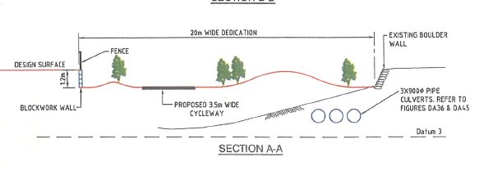
Figure 15: Approved Easement

MOD 10 as Originally Submitted (2016)

The submitted application outlined that the purpose of the swale was twofold, firstly to provide for stormwater management within Casuarina, and secondly to address the proposed land use interface with the adjoining northern residential dwellings.

Beyond this it was also noted that this easement is benefitted to Tweed Shire Council, and as such an application to extinguish same would need to be approved by Council.

It was proposed to locate a road within this 20m dedication, resulting in a reduced 8m wide buffer, as identified in and figures 16 and 17 below;

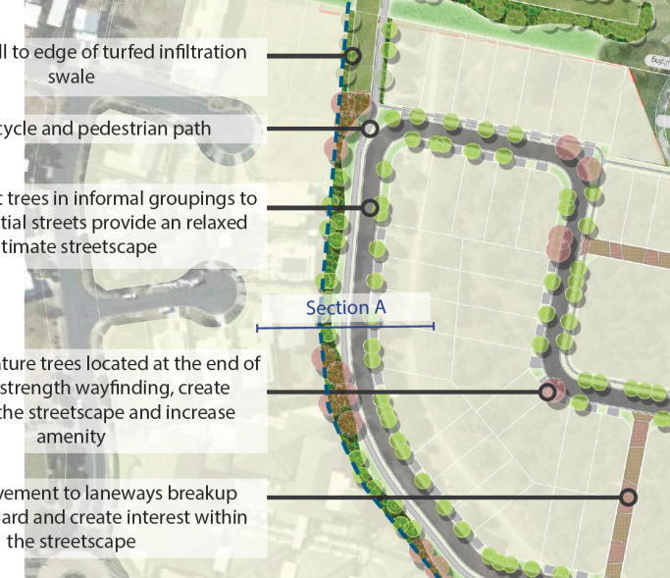
Figure 16: North Boundary Treatment with road

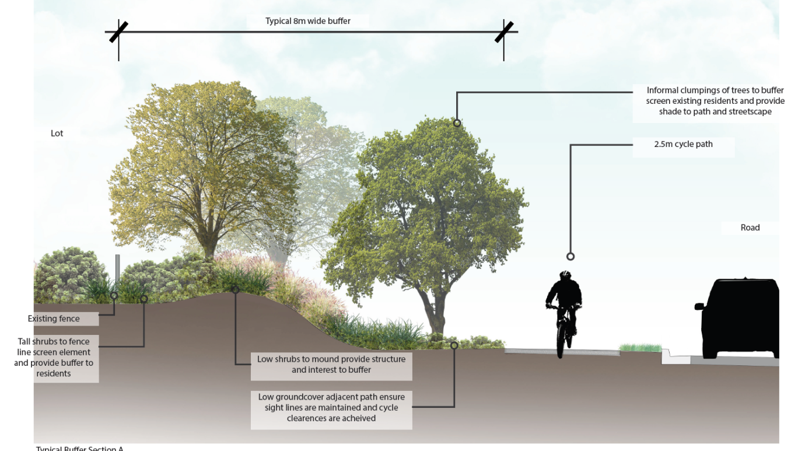
Figure 17: Concept drawing of proposed 8m wide buffer

Objections were raised to this element of MOD 10 by both Council officer and members of the public. Council officer concerns related to insufficient detail being provided to demonstrate that the stormwater measures would be adequate and inadequate justification for the reduction of the green buffer. Of relevance, Council submission to NSW Planning included the following;

‘In conclusion, it is considered that the proponent may be able to achieve the required stormwater/infrastructure provisions within the amended design, however sufficient information has not been provided as part of this application to demonstrate that all services can be located in the proposed area.

It is further considered that adequate justification for the reduction of a buffer area has not been provided as part of this application. This is in particular noted through the submission of correspondence from landowners to the north in opposition to this element of the proposal.

Council would request that the Department of Planning & Environment give consideration to the public submissions received with respect to this element of the modification and it is considered that without sufficient justification for a change to the approved layout, Council would prefer that the existing arrangement remain to this area.’

MOD 10 as Now Proposed under Response to Submissions (2017)

Subsequent to Council comments to NSW Planning the proponent has worked with Council officers to resolve the issues raised with the MOD 10 stormwater and green buffer reduction.

This has resulted in a revised subdivision layout which demonstrates a 20m buffer to the north site boundary area. Furthermore, the stormwater management now proposed is accepted by Council officers. Therefore Council’s previous concerns with this element of the proposal have been addressed satisfactorily. See below for further detailed comment in this regard.

Green Buffer Area
The revised development layout now proposed a 20m green buffer area to the north of the proposed northern road, as per figure 18 below;

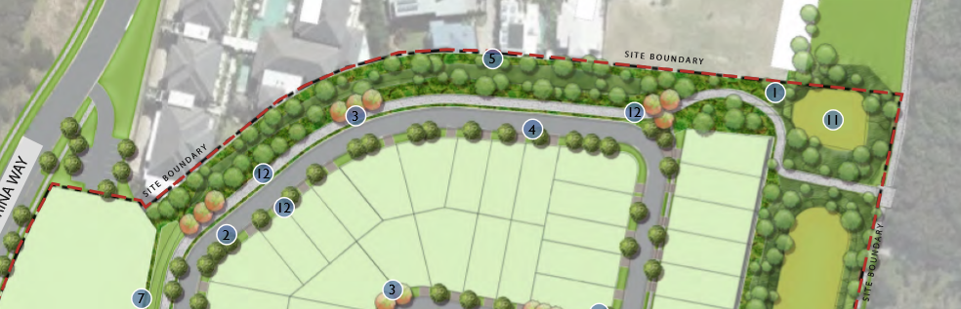
Figure 18: North Boundary Treatment with road

This maintains a buffer area consistent with the existing Major Project Approval and is therefore acceptable.

Stormwater Management
Concerns were raised with the initial modification application in that it proposed to significantly reduce the size of the piped trunk drainage system. The outcome was that the applicant’s consultant report was reviewed by a third party, which recommended a further change in stormwater design.

The stormwater design now proposed includes a 2.7m x 1.8m stormwater culvert as identified in figure 19 below. This has been reviewed by Council officers and is considered to be acceptable from a stormwater perspective.

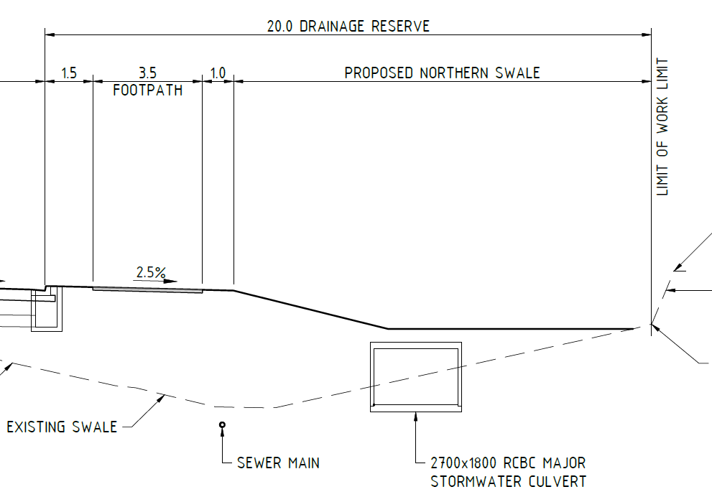
Figure 19: North Boundary Stormwater Treatment
The relevant Council Officer Engineering comments are provided below;

Manager Roads & Stormwater
Over the course of almost two years, Council officers have been working to resolve issues with the subject modification application with the proponents and their consultant engineers. With respect to public infrastructure (excluding water and waste water which is assessed by others) the main issue has related to the piping of the stormwater swale through the site. While this was approved in previous modifications, the subject subdivision application sought to further modify the plans for infrastructure and public space within the stormwater easement. This was important for a number of reasons, the main being:
- Demonstration that the proposed piped trunk drainage would have adequate capacity to cater for the 1% AEP storm event (or greater) without causing flooding of existing properties, future allotments, or the coastal reserve and beach areas;
- Provision of adequate alternate stormwater infiltration areas that are lost due to piping of the swale, to ensure downstream impacts of the development on Cudgen Creek are mitigated in accordance with the original master plan approvals for Casuarina;
- Provision of a suitable northern buffer between the town centre and existing residential development to the north, containing green space, walk/cycling paths, infrastructure services, and an overall positive urban design outcome.

Concerns were raised with the initial modification application in that it proposed to significantly reduce the size of the piped trunk drainage system. The outcome was that the applicant’s consultant report was reviewed by a third party, which recommended a further change in stormwater design. This was ultimately acceptable to Council and the applicant, and the modification application adjusted accordingly.

In undertaking these drainage changes and in response to community submissions, the 20m buffer along the northern boundary was also reinstated, to be clear of road infrastructure and private development. Again this is acceptable to Council officers, and amended plans now reflect this.

In order to achieve capacity and infiltration requirements, significant stormwater drainage infrastructure was proposed within the coastal reserve along the eastern frontage of the town centre site. Initially this consumed a large area, required levels that resulted in unsuitably high retaining structures on public land, and was judged by Council officers to be a poor outcome for the public reserve. Through a process of meetings and emailed correspondence, the applicant’s engineering consultants modified the landform and stormwater interface to produce a basin design that is now suitable to Council officers and accepted by the developer. The works on this parcel necessitated a review of the plan of management for community land, however it is assumed that this process has been resolved appropriately.

In terms of the modification application’s impacts on public infrastructure, I am satisfied with the applicant’s response to Council’s previous submissions, and the modified / updated plans and drawings.

Development Engineering Unit
‘… an external peer review is required to confirm pipe sizing. On 15 May 2017 a revised stormwater management plan and a peer review work was submitted to Council. Based on the findings it was agreed that a 2700x1800 RCBC was an acceptable solution.

Based on the above agreement of stormwater pipe sizing’s the other services (sewer, water, retaining walls, batters, pump station location etc…) was consequently updated and hence have now been accepted as appropriate.

It is now considered that the proposed drainage 2700x1800 RCBC pipe is an accepted drainage solution combined with a northern swale above including a 20m wide drainage reserve.

Changes to the timing for the provision of additional beach access

Under the current approval, Condition B5 of the Concept Approval requires the proponent to obtain approval from the relevant agencies regarding the provision of a proposed beach access to the east of the icon building. This is currently required prior to the issue of a construction certificate for balance of Stage 1 works. The applicant has requested that the approval be modified to have the access approved in Stage 2 in association with the development of the ‘Icon Building’ and surf lifesaving facilities.

To this end the applicant has provided an amended condition B5 which states that ‘Evidence of the approval for the construction of the beach access shall be provided to the Department prior to the issue of the Construction Certificate for the Icon Building.’

This has been previously reviewed by Councils Natural Resource Management Unit who have advised that there is ‘No objection to the proposed changes to timing for provision of additional beach access.’

Council has no objection to the amended timing for the beach access provision.

Changes to the approved staging plan

Amended staging of the development is proposed as part of the MOD 10 application. With respect to this, the information submitted in 2016 application states the following;

“Stage 1D is proposed to include the construction of the civil infrastructure and its associated dedication as a public asset, whilst Stage 1E will include the release of the remaining 92* lots (including 2 public reserves). Stage 1D will encompass the development of the balance of the road network (as amended), water, sewer, drainage, electricity and telecommunication infrastructure for the full Casuarina Town Centre. As part of the drainage works, the existing swale will be piped and filled and thereby established as a planted buffer with a shared pedestrian/cycleway path.

Stage 1E will then comprise the release of the balance of the subdivision for future residential housing, mixed use, commercial and retail development. The timing for the release of the lots within Stage 1E will occur based on market demand.”

*Planners Note: Stage 1E will now encompass 93 lots rather than 92 lots

The amended staging is demonstrated in figure 20 below;

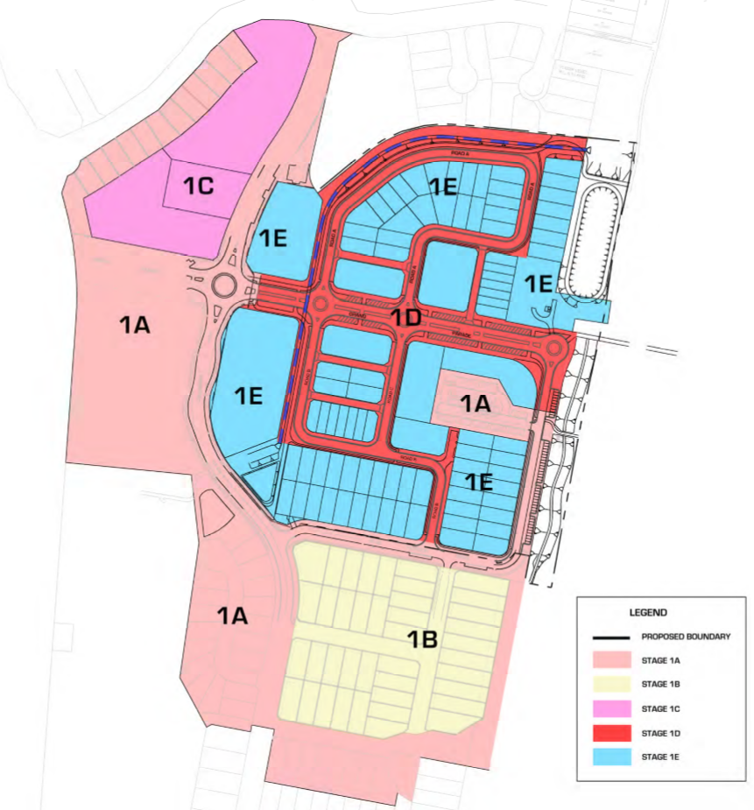
Figure 20: Proposed Staging plan

Council do not have any specific objections to the staging of the development in this manner, provided the provision of infrastructure (Stage 1D) occurs prior to the release of allotments (Stage 1E).

Administrative changes to the conditions of approval in response to the above changes.

As outlined in the comments contained elsewhere in this report, it is considered that minor clarification/amendment is required with respect to the proposed modification application. In the event that this is satisfactorily addressed and MOD 10 approved, it is considered likely to necessitate the amendment to the conditions of approval. Tweed Shire Council would welcome an opportunity to comment/review conditions of approval prior to the application being finalised.

Key amendments proposed in RtS include:
- relocation of the local road outside the 20 metre green buffer to the northern boundary; and
- an increase in lots in Stage 1E from 92 lots to 93 lots.

Relocation of the local road outside the 20 metre green buffer to the northern boundary

The background with respect to the 20m green buffer to the northern boundary is detailed elsewhere in this report (under ‘revise the drainage concept to facilitate the filling of an existing drainage swale and its conversion to a ‘green buffer’ heading).

Through the Response to Submissions the proponent has amended the application to reinstate the 20m green buffer where it adjoins residential accommodation to the north, as demonstrated in figure 21 below;

Figure 21: North Boundary Treatment with road

This is supported by Council staff.

Increase in lots in Stage 1E from 92 lots to 93 lots.
An additional allotment is now proposed as part of the Casuarina Town Centre to the highlighted area below from the layout submitted under the original MOD 10 application. It is noted that this area is not subject to a minimum lot size under Tweed Local Environmental Plan 2014. Council officers raise no objection to this additional allotment.

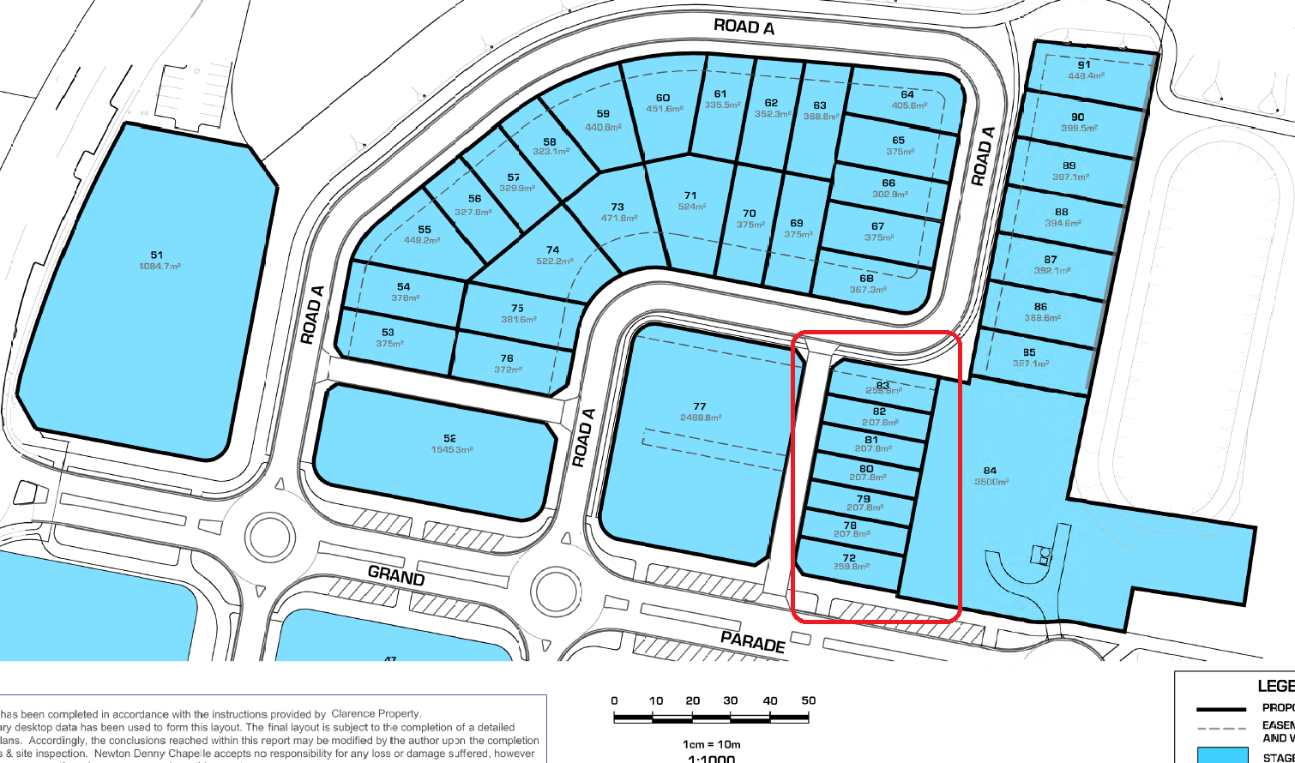
Figure 22: Additional allotment

Miscellaneous
Owners consent/ Plan of Management for LOT 13 DP 1014470

The proposed modifications to Casuarina Town Centre include works on Council owned Community Land (Lot 13 DP 1014470). See area highlighted and in yellow below;

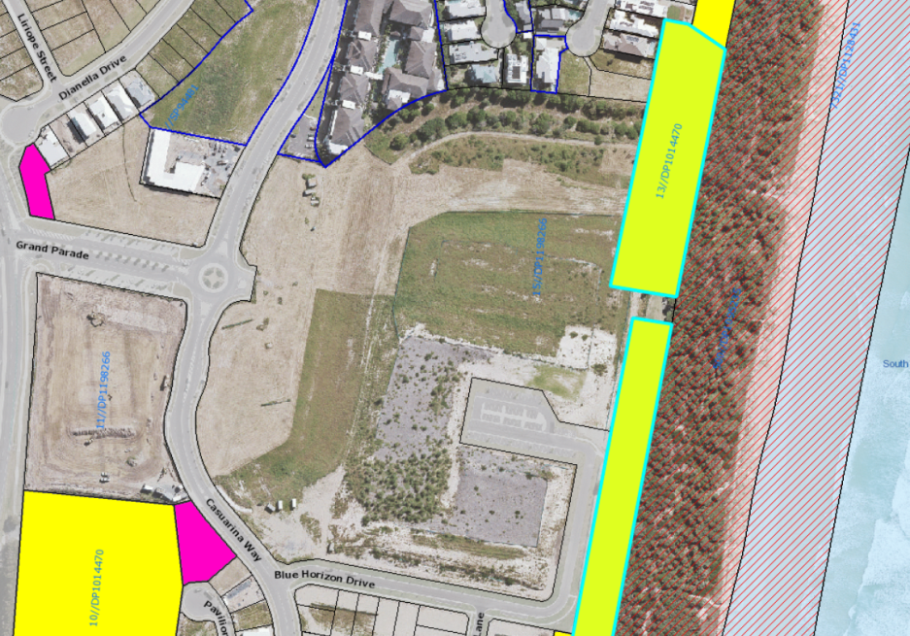
Figure 23: Lot 13 DP 1014470

In association with the Casuarina Town Centre Concept Plan this land was always intended to be used for some form of park and public infrastructure however the details of this space have now been further confirmed in MOD 10 and outlined in the lodgement of a “Plan of Management” for this area which has resulted from a major amendment to the stormwater drainage system for the site.

At the Council meeting held on 21 September 2017, Council resolved to place a draft Plan of Management for LOT 13 DP 1014470 on public exhibition. The draft Plan of Management will be on public exhibition from 8 November 2017 to 6 December 2017, with submissions being accepted until 20 December 2017.

Prior to finalising the MOD 10 application, NSW Planning are requested to confirm with Council that the Plan of Management has been adopted by Tweed Shire Council to ensure that the works proposed as part of this application are reflected in the Plan of Management for Lot 13 DP 1014470

OPTIONS:

1. Council endorses the comments to be submitted to NSW Planning & Environment with regard to Response to Submissions (RtS) on modifications of the Concept Approval and Project Approval relating to Casuarina Town Centre (MP06_0258) MOD 10; or

2. Council does not endorse the attached comments to be submitted to NSW Planning & Environment and either provides amended comments or elects to make no submission on this Modification application.

Council officers recommend Option 1.

CONCLUSION:

It is considered that additional information and possible design amendments are required in order for the proposed modification to receive the conditional support of Tweed Shire Council, as outlined in the above report. It is recommended that the Department of Planning and Environment be advised of this and requested to take Council comments into account when assessing the modification application.

COUNCIL IMPLICATIONS:

a. Policy:
Corporate Policy Not Applicable.

b. Budget/Long Term Financial Plan:
Not Applicable.

c. Legal:
Not Applicable.

d. Communication/Engagement:
Not Applicable.

UNDER SEPARATE COVER/FURTHER INFORMATION:

Attachment 1. DA10/0226.26 Council Report - 21 April 2016 (ECM 4759627)

Attachment 2. DA10/0226.26 Council Report – 21 September 2017 Draft Plan of Management (ECM 4759581)

