Westfield Parramatta Shopping Centre Concept Plan Modification 1
Commercial tower modifications
Section 75W Modification Assessment (MP 10_0068 MOD1)
August 2021
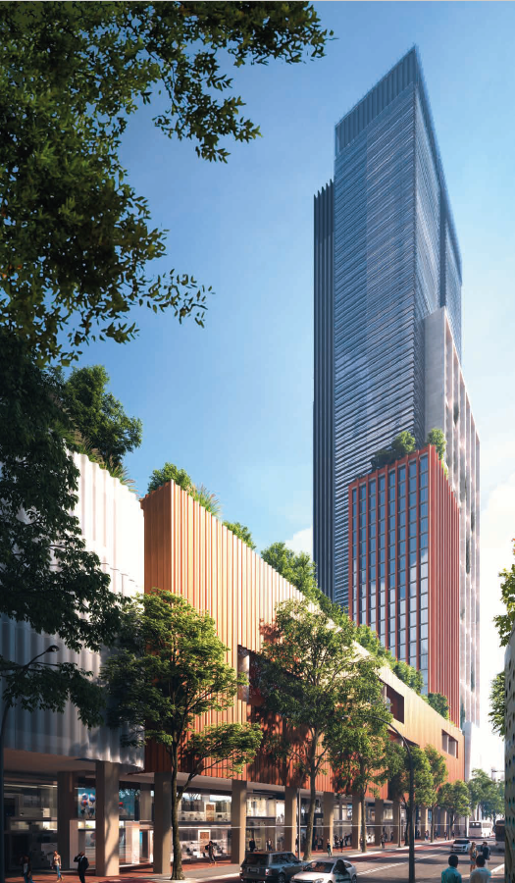
Published by the NSW Department of Planning, Industry and Environment
dpie.nsw.gov.au
Title: Westfield Parramatta Shopping Centre Concept Plan MOD 1
Subtitle: MP 10_0068 MOD 1
© State of New South Wales through Department of Planning, Industry and Environment 2021. You may copy, distribute, display, download and otherwise freely deal with this publication for any purpose, provided that you attribute the Department of Planning, Industry and Environment as the owner. However, you must obtain permission if you wish to charge others for access to the publication (other than at cost); include the publication in advertising or a product for sale; modify the publication; or republish the publication on a website. You may freely link to the publication on a departmental website.
Disclaimer: The information contained in this publication is based on knowledge and understanding at the time of writing August 2021 and may not be accurate, current or complete. The State of New South Wales (including the NSW Department of Planning, Industry and Environment), the author and the publisher take no responsibility, and will accept no liability, for the accuracy, currency, reliability or correctness of any information included in the document (including material provided by third parties). Readers should make their own inquiries and rely on their own advice when making decisions related to material contained in this publication.

Glossary
Abbreviation | Definition
CBD PP | Parramatta CBD Planning Proposal
Council | City of Parramatta Council
Department | Department of Planning, Industry and Environment
PDCP | Parramatta Development Control Plan 2011
EIS | Environmental Impact Statement
EP&A Act | Environmental Planning and Assessment Act 1979
EP&A Regulation | Environmental Planning and Assessment Regulation 2000
EPI | Environmental Planning Instrument
GFA | Gross Floor Area
GFLA | Gross Floor Leasable Floor Area
LEP | Local Environmental Plan
SEARs | Planning Secretary’s Environmental Assessment Requirements
Planning Secretary | Secretary of the Department of Planning, Industry and Environment
SEPP | State Environmental Planning Policy
SRD SEPP | State Environmental Planning Policy (State and Regional Development) 2011
SSD | State Significant Development
Westfield Parramatta | Westfield Shopping Centre at Parramatta

Executive Summary

Introduction
This report provides an assessment of a Section 75W modification application (MP 10_0068 MOD 1) seeking to amend the concept approval for a commercial tower envelope above the Westfield shopping centre at 159 Argyle Street, Parramatta, in the Parramatta Local Government Area (LGA).
The modification request seeks approval to relocate of the commercial tower envelope 100 m west to the corner of Argyle Street and Marsden Street, increase the gross floor area (GFA) from 35,000 m² to 105,000 m² (+70,000 m²), increase the maximum building height from RL 131 m to RL 220 m (+ 89 m) and changes to the podium, car parking and upgrades to the public domain.
The application has been lodged by Scentre Group (the Proponent) pursuant to section 75W of the Environmental Planning and Assessment Act 1979 (EP&A Act).

Engagement
The Department of Planning, Industry and Environment (the Department) publicly exhibited the modification request between 5 September 2018 until 2 October 2018 (28 days) and the Proponent’s Response to Submissions (RtS) between 2 December 2020 to 15 December 2020 (14 days). The Department received a combined total of twenty submissions, including 10 submissions from public authorities, three from City of Parramatta Council (Council) and seven from the public.
The key concerns raised in public submissions relate to the tower height and location, overshadowing, visual impacts and parking. Council initially objected to the proposal however it withdrew its objection following amendments to the proposal submitted with the RtS. Council provided comments regarding the building floorplate size and façade length, the design excellence strategy and matters to be included in the design competition.
The Proponent provided a response to the issues raised in submissions and additional information in support of the proposal. In addition, the Proponent amended the proposal by moving the tower further west to the corner of Argyle and Marsden Street and reducing the proposed maximum floor plate and overall GFA. The Proponent also prepared a detailed design excellence strategy to guide future DA(s).

Assessment
The Department has assessed the proposed modification in accordance with the relevant requirements of the EP&A Act and has carefully considered the issues raised in public submissions and the Proponent’s response. The Department’s assessment concludes that the proposal is acceptable as:
- it is consistent with the Region Plan, Central City district plan and other strategic planning policies which all aim to promote the growth of the Parramatta CBD as a key commercial and civic centre for Sydney
- the proposed building height fully complies with the Central Business District Planning Proposal (CBD PP) and is consistent with the evolving character of Parramatta which includes other tall buildings at 8 Parramatta Square (RL 261 m) and the Planning Proposal approved at 2 O’Connell Street (RL 250 m)
- the Department has recommended conditions to address concerns raised about the visual bulk of the proposal including a minimum 20% building articulation zone and a maximum east-west length of the future building of 60 m (consistent with Council’s draft planning controls)
- it would not result in any unacceptable heritage impacts as the building envelope is setback 12 m from the alignment of Church Street, will have a maximum east-west length of 60 metres and FEARs are recommended to ensure the future massing, design and materials of the building minimise visual impacts to Old Government House and the Domain (OGHD), St John’s Anglican Cathedral and the Church Street view corridor
- it would not result in any adverse traffic impacts as the site has excellent access to existing and planned public transport and proposes 20 less car parking spaces than originally approved and loading and servicing requirements, impacts and any mitigation measures will be assessed in the future DA
- it would not result in unreasonable view loss, overshadowing, wind or other amenity impacts to neighbouring properties and the public domain
- it will improve streetscape activation, facilitate the upgrade of the public domain along Argyle and Marden Streets and the future DA would provide up to 700 construction and 2,200 operational jobs
- the Department recommends a suite of conditions to ensure:
  - a design competition is held prior to the submission of the future DA and a Design Integrity Panel is established to ensure the future building achieves design excellence
  - the maximum east-west building length does not exceed 60 m, and a minimum articulation zone of 20%
  - the materials, finishes, design and signage minimise visual impact and reflectivity impacts when viewed from OGHD
  - the future DA assesses, manages and mitigates potential impacts associated with traffic, transport, servicing, aviation safety, Sydney Trains requirements, contamination and environmental performance.

Conclusion
Overall, the Department’s assessment concludes the proposal is acceptable as it is consistent with the strategic planning framework adopted for the site, is of an appropriate height, density and scale and would not result in adverse amenity, heritage, or traffic impacts.
The issues raised by Government agencies, Council and the community have been addressed in the proposal, the Department’s assessment report or by recommended conditions of approval.
The Department’s assessment therefore concludes the proposal would result in benefits to the local community and NSW and is therefore in the public interest, subject to conditions.
Contents
Executive Summary 3
Introduction 3
Engagement 3
Assessment 3
Conclusion 4
1 Introduction 8
1.1 Introduction 8
1.2 The site 8
1.3 Relevant Planning History 10
2 Proposed Modification 12
3 Strategic Context 16
3.1 Greater Sydney Region Plan and Central District Plan 16
3.2 Greater Parramatta and Olympic Peninsula Vision 16
3.3 Future Transport 2056 16
3.4 Greater Parramatta Interim Land use and Infrastructure Implementation Plan 17
3.5 Parramatta CBD Planning Proposal 17
4 Statutory Context 19
4.1 Modification of the Minister’s Approval 19
4.2 Approval authority 19
4.3 Planning Secretary’s Environmental Assessment Requirements 19
4.4 Environmental Planning Instruments 20
4.5 Objects of the EP&A Act 20
4.6 Environmental Protection and Biodiversity Conservation Act 1999 20
5 Engagement 21
5.1 Department’s engagement 21
5.2 Submissions 22
5.3 Key issues – Council 23
5.4 Key issues – Community 24
5.5 Response to submissions 25
6 Assessment 27
6.1 Built Form 27
6.2 Design Excellence 31
6.3 Heritage 33
6.4 Parking, Traffic and Transport 36
6.5 Other issues 39
7 Evaluation 44
8 Recommendation 46
9 Determination 47
Appendices 48
Appendix A – Relevant Supporting Information 48
Appendix B – Modification Report 48
Appendix C – Consideration of Environmental Planning Instruments 48

Introduction

Introduction
This report provides an assessment of an application to modify the concept plan for the extension of the Westfield Shopping Centre at Parramatta (Westfield Parramatta) (MP10_0068) pursuant to section 75W of the Environmental Planning and Assessment Act 1979 (the EP&A Act).
The modification application (as amended) seeks approval to:
- relocate the tower envelope to the corner of Marsden and Argyle Street
- increase the tower gross floor area (GFA) from 35,000 m² to 105,000 m²
- increase the maximum tower height from RL 131 m to RL 220 m)
- increase the indicative office floor levels from 25 to 47
- provide a maximum envelope width of 71.5 m along Argyle Street and 45.435 m along Marsden Street
- increase the maximum floorplate area to 2,534 m² (GFA)
- relocate the office tower lobby and entry from Church Street to the corner of Argyle Street and Marsden Street
- improve integration with the podium retail levels and enhance activation and access to Argyle Street and Marsden Street
- provide an additional basement level for car parking and servicing under the tower.
The application has been lodged by Scentre Group (the Proponent) pursuant to section 75W of the Environmental Planning and Assessment Act 1979 (EP&A Act).

The site
The site is the Westfield shopping centre, located at 159 Argyle Street, Parramatta. It is located in the southern portion of the Parramatta Central Busines District (CBD) in the City of Paramatta local government area (LGA) (Figure 1).
The Westfield shopping centre is predominantly located between Argyle and Campbell Streets and extends from Parramatta railway station in the east to St John’s Cemetery and O’Connell Street in the west (Figure 2). The centre is divided into three building segments separated by Church Street and Marsden Street and linked above Church and Marsden Streets by pedestrian bridges and vehicular ramps across Marsden Street that allow for car park access and vehicular circulation.
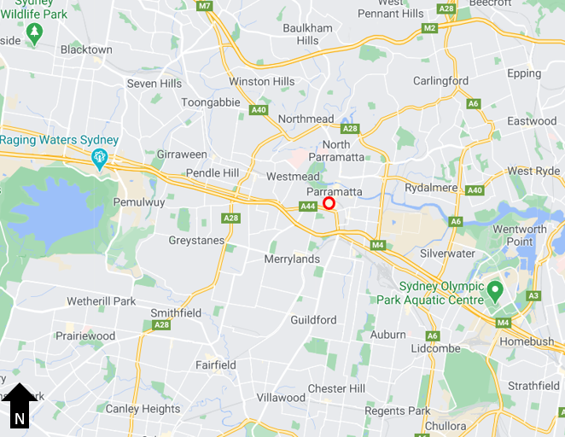
Figure 1 | Site Location (red) (Source: Nearmaps)
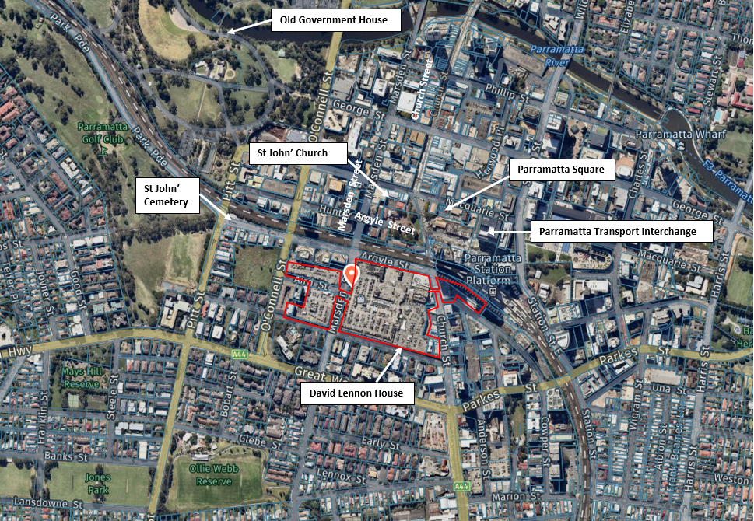
Figure 2 | Ariel view of the site (red) and its immediate surroundings (Base source: Nearmap)
The site is surrounded by a wide variety of land-uses, building heights, architectural styles and development densities and scales. The land north and east of the site is predominantly commercial in nature, while the land to the south and west is residential. Neighbouring developments present a range of heights from single and 2-storey houses to commercial towers up to 56-storeys (RL 261) (Figure 3).
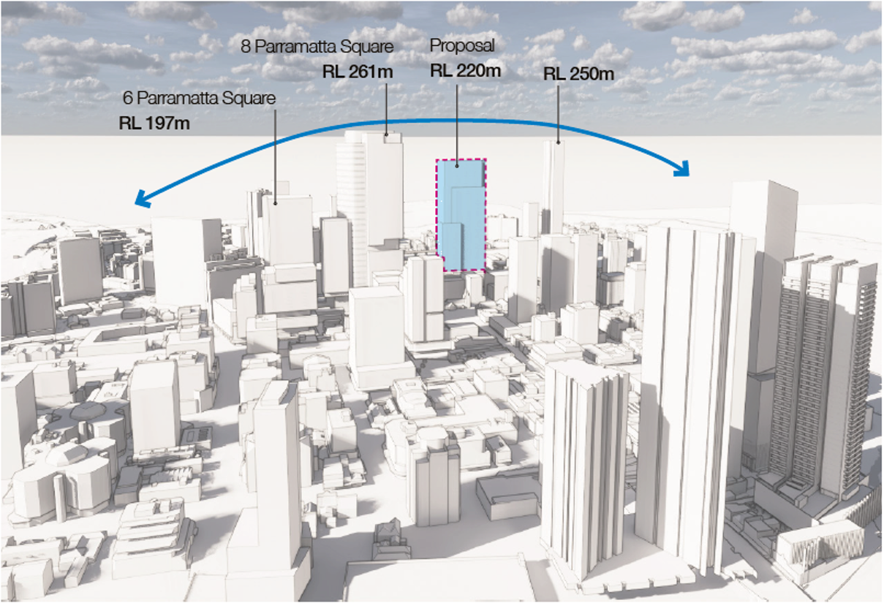
Figure 3 | CGI of the modified envelope and tall buildings (constructed and approved) since the original concept approval (Proponent’s RtS)
The site is not located within a Conservation Area nor does it contain any items of heritage significance. However, there are several heritage listed items near the centre, notably Old Government House, St Johns Cemetery, Parramatta Station and David Lennox House which are all of State heritage significance (Figure 2).

Relevant Planning History

1.2.1 Concept Approval (MP 10_0068)
On 20 February 2014, the then Planning Assessment Commission approved a concept plan for retail additions to the existing shopping centre incorporating:
- 31,495m² (GFA) of retail additions and associated internal modifications
- a building envelope for commercial tower above retail podium incorporating up to 35,000m² (GFA) commercial floor space
- parking for 562 vehicles
- associated public domain works
- road infrastructure works to support the development.

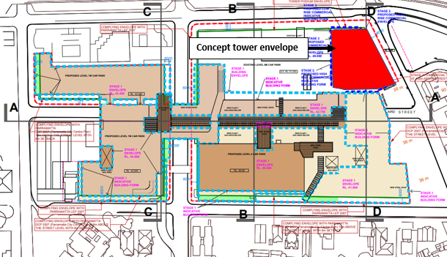
Figure 1 | Approved Concept Plan showing the location of tower envelope in red (Base Source: Proponent’s EIS)

1.2.2 Stage 1 Approval (MP 10_0068 (PA))
On 20 February 2014, the then Planning Assessment Commission approved a Stage 1 Project Approval at Parramatta Westfield for:
- a total 31,495m² (GFA) of additional floor space
- one additional retail level and three additional parking levels
- various related modifications throughout the building
- additional 562 car spaces
- associated public domain and art works
- road infrastructure works to support the development.
The application has been modified once on 28 August 2018 (MP 10_0068 (PA) (MOD 1)) to allow for staged construction and the payment of contributions in instalments.
The Proponent submitted a letter from a Building certifier confirming the project approval commenced on 8 February 2018.

Proposed Modification
The modification request seeks approval to amend the commercial tower envelope location, height and gross floor area (GFA).
The proposal initially sought to relocate the tower envelope to the middle of the site along Argyle Street and increase the GFA from, 35,000 m² to 112,000 m². In response to concerns raised during exhibition and by the Department, the Proponent amended the proposal to reduce the GFA to 105,000 m² and re-locate the tower further south to the corner of Argyle Street and Marsden Street.
The key components and features of the proposal (as amended) are summarised at Table 1. A link to the application is provides at Appendix A. The modification is shown at Figure 5 to Figure 7
Table 1 | Main components of the modification
Component | Description
Building Envelope | - Relocate the office tower envelope from the corner of Argyle Street and Church Street approximately 100 metres south to the corner of Argyle Street and Marsden Street  - Increase the tower maximum envelope height from RL 131 m to RL 220 m (+89 m) and the number of indicative office floor levels from 25 to 47 (+23)  - Increase the maximum tower floor area from 1,400 m² to 2,534 m² (GFA)
Gross floor area (GFA) | - Increase the maximum tower GFA from 35,000 m² to 105,000 m² (+ 70,000 m²)
Podium | - Relocate the future office lobby entrance to the corner of Marsden and Argyle Street and upgrade the podium façade beneath the tower
Basement / Car parking | - Provide a new two-level basement to accommodate car parking and servicing for the office tower  - Relocate 100 approved car parking spaces to within the new basement
Public domain and landscaping | - Public domain upgrades extended to include the length of Argyle Street and Marsden Street
Design Excellence | - Competitive Design Excellence Strategy, which includes a competition framework to select a design that delivers design excellence prior to any future development applications.
Statement of Commitments (SoCs) | - Update the Statement of commitments to include:  - a requirement for a design competition prior to future DA(s)  - street activation and podium upgrades below the tower as part of future DA(s)  - extend public domain upgrades along the length of Argyle Street and Marsden Street

A comparison between the key elements of the concept approval and proposed modification is provided in Table .
Table 2 | Comparison of key elements of the concept approval and proposed modification
Component | Concept Approval | Proposed Modification | Difference (+/-)
Tower envelope height (max) | RL131 | RL 220 | +89 m
Tower Envelope maximum dimensions | - 45m wide  - 40 m deep | - 71m wide  - 45 m deep | - +26m  - +5m
Minimum tower setbacks from street frontages | 8m (tower plinth)  20 m (tower) | 6 m | -14 m
Maximum floor area (GFA) | 1,400 m² | 2,534 m² | +1,134 m²
Car Parking | 562 spaces | 542 spaces | -20 spaces

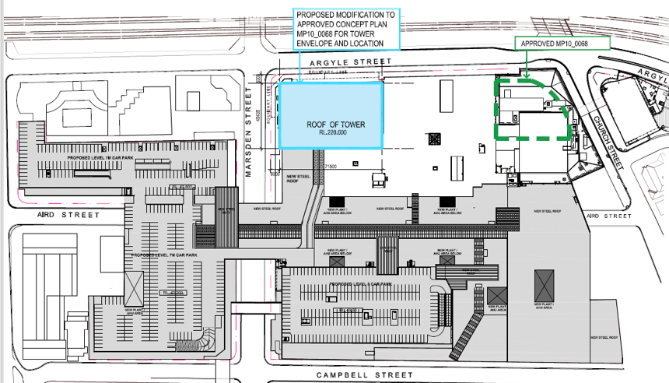
Figure 5 | Approved (green) and proposed (blue) tower envelope location (Source: Proponent’s RtS)
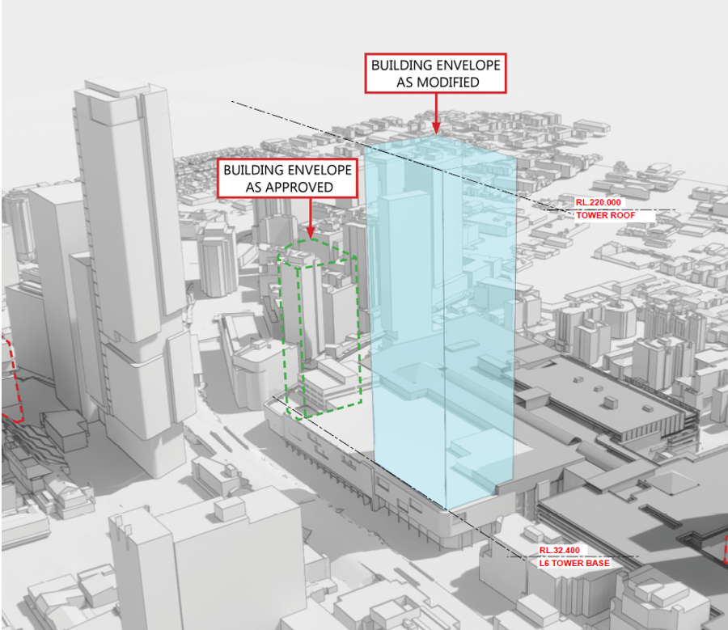
Figure 6 | Approved (green) and proposed (blue) tower envelope location (Source: Proponent’s RtS)

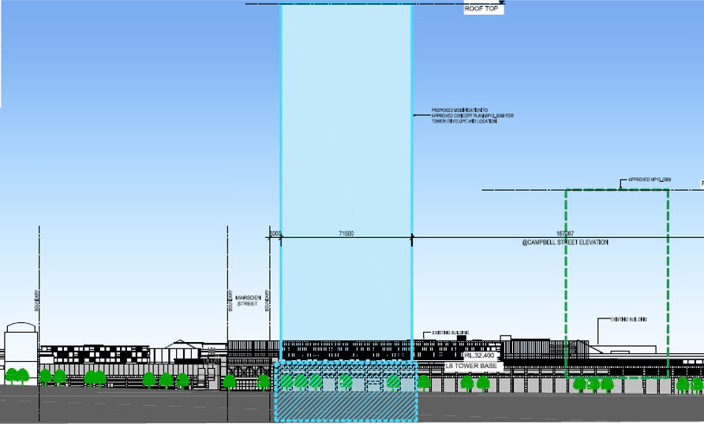
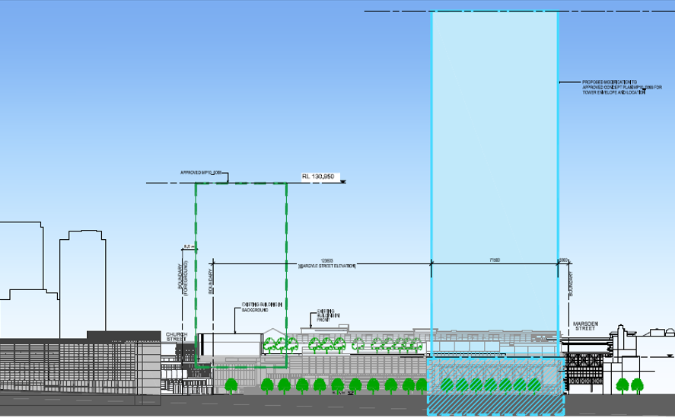
Figure 7 | Approved (blue) and proposed (green) tower envelope east (above) elevation and west (below) elevations.

Strategic Context

Greater Sydney Region Plan and Central District Plan
The Greater Sydney Commission’s (GSC) role is to coordinate and align planning to shape the future of Metropolitan Sydney. In March 2018, the GSC published the Greater Sydney Region Plan (the Region Plan) and the associated District Plans.
The Region Plan outlines how Greater Sydney will manage growth and change and guide infrastructure delivery. It sets the vision and strategy for Greater Sydney, to be implemented at a local level through District Plans. The site is located within the Central District and the Greater Parramatta and Olympic Peninsula (GPOP) Economic Corridor. The modification is consistent with the Region Plan and the Central District Plan, as:
- the proposal will provide new commercial office space in the heart of the Central City District and GPOP with excellent access to surrounding jobs, services and surrounding strategic centres
- the site has excellent access to existing and planned public transport connections including Parramatta Station and local bus routes, Parramatta light Rail and Sydney MetroWest
- the proposal will contribute to the long term strength of the economy providing employment and investment in the GPOP economic corridor and the Parramatta CBD

Greater Parramatta and Olympic Peninsula Vision
The GPOP vision identifies the Parramatta CBD as the commercial and civic central of the Economic Corridor and sets out a city shaping vision for the GPOP as an engine of the economy and a centre of creativity and innovation by 2036 and beyond:
The modification supports the key directions of the GPOP vision as it would:
- provide for strong investment momentum within Parramatta CBD which is the principal economic anchor of the GPOP economic corridor
- achieve design excellence (subject to a future design competition at Stage 2) and contribute the prominence of Parramatta CBD

Future Transport 2056
The Future Transport Strategy 2056 is an update to the NSW Long Term Transport Master Plan 2012 and outlines a planned and coordinated set of actions to address challenges faced by the NSW transport system to support the State’s economic and social performance over the next 40 years.
The proposal is consistent with the key outcomes of the Plan as the site is located within walking distance to a number of public transport services, it will encourage active transport travel options by providing bicycle parking spaces and end of trip facilities (subject to future assessment) and on-site car parking spaces are limited reduced to encourage the use of public transport.

Greater Parramatta Interim Land use and Infrastructure Implementation Plan
The Department’s Greater Paramatta Interim Land Use and Infrastructure Implementation Plan (LUIIP) identifies the land use framework to guide future development in Greater Parramatta over the next 20 years. The plan recognises Parramatta CBD as a commercial core, civic heart employment, education and research hub.
The proposal is consistent with the Key Actions the LUIIP as it would attract investment, provide employment and promote economic growth within the Parramatta CBD and Greater Parramatta.

Parramatta CBD Planning Proposal
The Parramatta CBD Planning Proposal (CBD PP) was publicly exhibited from 21 September 2020 to 2 November 2020. On 15 June 2021, Council resolved to approve the CBD PP, which was submitted to the Department for finalisation on 6 July 2021.
The CBD PP recommends a new draft land use planning framework for the Parramatta CBD and seeks to amend the planning controls for the Parramatta CBD as identified in the Parramatta Local Environmental Plan (LEP) 2011. The CBD PP seeks to modify the Parramatta CBD boundary, land use mix, primary built form controls and the mechanisms for infrastructure delivery. In relation to the subject site the CBD PP proposes:
- to extend the B3 “commercial core” zone to include the site
- increase FSR from 4:2:1 to 10:1
- a maximum height ranging from 36 m to RL 211 m
- a 15% height bonus provided design excellence is achieved.
Council is also currently preparing amendments to the Parramatta Development Control Plan 2011 (PDCP) in order to deliver more detailed controls to guide future built form and support the LEP changes proposed in the CBD Planning Proposal.
The proposal complies with the maximum height and floor space in the CBD PP. In addition, the Department has recommended the maximum east-west length of the building be limited to 60 m consistent with Council’s draft DCP amendment which will apply to all future development in the CBD. The Department’s detailed assessment of built form is provided in Section 6.1.
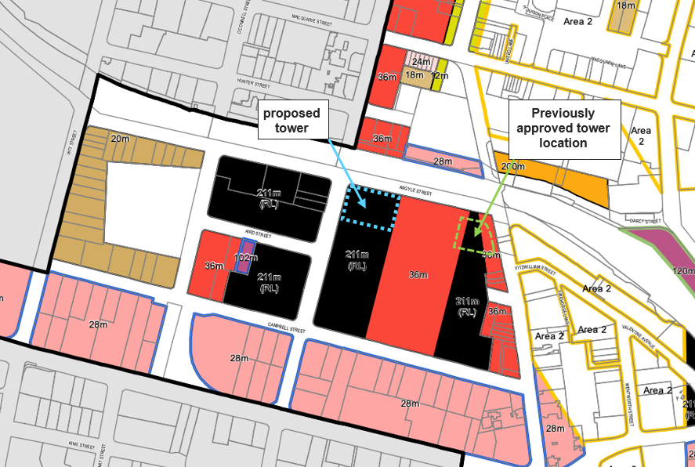
Extension of 12m Church Street setback line
Figure 8 | Draft LEP Building height (211 m) applying to the site and the Approved (green) and Proposed (blue) tower envelope location (Base Source: Parramatta Council Submission)

Statutory Context

Modification of the Minister’s Approval
The concept plan was originally approved under Part 3A of the EP&A Act. This means the project satisfied the definition of a ‘transitional Part 3A project’ under clause 2(1) Schedule 2 to the Environmental Planning and Assessment (Savings, Transitional and Other Provisions) Regulation 2017 (STOP Regulation), which came into effect on 1 March 2018.
Under the STOP Regulation, the power to modify transitional Part 3A projects under section 75W of the Act, as in force immediately before its repeal on 1 October 2011 is being wound up – but as the request for this modification was made before the ‘cut-off date’ of 1 March 2018, the provisions of Schedule 2 (clause 3) continue to apply.
As the Proponent made a request to modify the Part 3A approval and requested Secretary’s Environmental Assessment requirements (SEARs) for the proposal on 4 September 2017 (before 1 March 2018), the Part 3A provisions and specifically the power under Section 75W to modify the approval continue to apply to and in respect of the project (clause 3 and 3BA of Schedule 2 to the ST&OP Regulation). Consequently, the assessment of this request is required to be prepared in accordance with the requirements of Part 3A and relevant regulations. The Minister (or his delegate) may approve or disapprove the carrying out of the project under section 75W of the EP&A Act.
The Department of Planning Industry and Environment (Department) is satisfied the proposed changes are within the scope of section 75W of the EP&A Act, and do not constitute a new application.
Section 6 of this report provides an assessment of the impacts associated with this proposal.

Approval authority
The Minister for Planning and Public Spaces is the approval authority for the modification applications. However, the Executive Director, Key Sites and Regional Assessments, may determine the application as:
- a political disclosure statement has not been made
- Council has withdrawn its initial objection to the proposal
- less than 15 public submissions in the nature of objections were received.

Planning Secretary’s Environmental Assessment Requirements
On 29 September 2017, the Secretary notified the Proponent of the Environmental Assessment Requirements (SEARs) for the section 75W modification request (MP 10_0098 MOD 1).
The Department has reviewed the Environmental Assessment against the SEARs and is satisfied that it adequately provides the information required in the SEARs to enable the assessment and determination of the modification request.

Environmental Planning Instruments
The following Environmental Planning Instruments (EPIs) are relevant to the application:
- State Environmental Planning Policy (State and Regional Development) 2011
- State Environmental Planning Policy (Infrastructure) 2007
- State Environmental Planning Policy 55 – Remediation of Land (SEPP 55)
- Draft State Environmental Planning Policy (Remediation of Land) (draft Remediation SEPP)
- Parramatta Local Environmental Plan 2011
- Draft CBD PP.

The Department is satisfied that the proposed modification does not result in any changes that would alter the conclusions made as part of the original assessment of the concept plan in relation to the EPIs or any subsequent replacement EPIs. The Department has assessed the proposed basement against SEPP 55 and draft Remediation SEPP at Appendix C.

Objects of the EP&A Act
The Minister or delegate must consider the objects of the EP&A Act when making decisions under the Act. The Department is satisfied the proposed modification is consistent with the objects of the EP&A Act.

Environmental Protection and Biodiversity Conservation Act 1999
The site is located within 500 metres of the south eastern boundary of the OGHD, which is an area of national environmental significance (NES) and protected under the Environmental Protection and Biodiversity Conservation Act 1999 (EPBC Act). Under the EPBC Act, a person must not take an action that has, will have, or is likely to have a significant impact on matters of NES without the approval of the Australian Government Minister for the Environment.

The proponent is required to determine whether an action is likely to have a significant impact. The Federal Department of Environment (FDE) also provides formal advice on whether a proposed action will have a significant impact and therefore be a ‘controlled action’.

Although the Proponent is required to undertake an assessment to determine whether the project would result in significant impacts obtain approval under the EPBC Act for the controlled action, this has not been sought (under any bilateral agreement) as part of this assessment and therefore does not prevent the determination of the modification application under the EP&A Act. The Department therefore recommends an advisory note reminding the proponent to undertake the necessary assessment and obtain EPBC Act approval if required.

Engagement

Department’s engagement
On 6 August 2018, the Proponent lodged the Section 75W modification application. The application has been updated twice by the:
- Response to submissions (RtS), dated 17 December 2020; and
- Further Response to Submissions (FRtS) received 30 April 2021
The Department publicly exhibited the EA and the RtS and notified the FRtS. A total of 20 submissions were received in response to the exhibition of to the EA, RtS and FRtS comprising 10 from government agencies, three from Council and seven from the public. A summary of the exhibition and notification is provided in Table 3.
Table 3 | Summary of public exhibition and notification of the application
Stage | Exhibition/Notification Period | Consultation Method | Submissions
EA | 5 Sep 2018 to 2 October 2018 (28 days) | Displayed:  - Department’s website  - Council’s office  - NSW Service Centre  Notified:  - Adjoining landowners  - Council  - Government Agencies | 12 Submissions comprising:  - Council  - 6 Government Agencies  - 5 public
RtS | 2 December to 15 December 2020 (14 days) | Displayed on the Department’s website.  Notified:  - Adjoining landowners  - Previous submitters  - Council  - Government Agencies | 6 Submissions comprising  - Council  - 3 Government Agencies  - 2 public
FRtS | 30 April 2021 | Displayed on the Department’s website  Notified:  - Council  - Government Agencies | 2 submissions comprising  - Council  - 1 Government Agency

The Department has considered the comments raised in the public, Council and government agencies submissions during the assessment of the application (Section 6) and in the recommended conditions of approval at Appendix D.
A summary of submissions and the issues raised in submissions is provided at Section 5.2. copies of the submissions may be viewed at Appendix B

Submissions
5.2.1 Public Authority Submissions
A summary of the issues raised by government agencies is provide at Table 4
Table 4 | Government Agency submissions
TfNSW and RMS
EA | TfNSW does not object to the modification and provided the following comments:  - the indicative active frontage /retail seating along Argyle Street below the tower has possible impacts on pedestrian flows  - the Proponent should provide:  - details of pedestrian movements along Argyle Street including LoS analysis  - detailed freight/servicing analysis and potential mitigation measures  - any changes to bus stops should be agreed with TfNSW  - the Proponent should consult with TfNSW, RMS and Council during preparation of a Construction and Pedestrian Traffic Management Plan (CPTMP)  - future DA(s) should provide a separate bicycle facility in the proposed loading dock access.  RMS does not object to the modification and provided the following comments:  - a workplace travel plan should be implemented to encourage public transport use  - all works/regulatory signposting are to be at no cost to RMS  - the road upgrade requirements of condition B6 of the project approval should be conditioned to be delivered as part of the Stage 2 DA for the tower  - a workplace travel plan should be required and implemented.
RtS/FRtS | TfNSW does not object to the proposal and provided the following comments:  - RMS’ previously suggested conditions should be imposed  - the road upgrade requirements of Condition B6 of the project approval should be conditioned to be delivered as part of stage 1.3 of the Project Approval  - conditions requiring Stage 2 DA(s) include a draft Loading and Servicing Management Plan, Construction Pedestrian and Traffic Management Plan and Green Travel Plan.
Office of Environment and Heritage (Heritage NSW)
EA | Heritage NSW does not object to the modification however provided the following comments/concerns:  - the location, bulk, and scale of the tower needs to be revised to mitigate the adverse visual impact on the historic view corridors and settings of landmark heritage items in the vicinity, specifically the historic views form the north of St. John’s Church  - the materials, finishes and design of the tower elevations are to minimise the visual dominance and reflectivity of the tower in relating to St John’s Church and views from Old Government House and Domain  - external building signage should be located at lower levels.
RtS | Heritage NSW advised the amendments have addressed the previous concerns in relation to the location of the tower, however raised concern that:  - the proposed height and bulk of the tower is still considered excessive  - the towers height and bulk would still dominate the skyline in the vicinity of several State Heritage items and impact the significant views from Old Government House and Domain  Heritage NSW recommended that conditions regarding design and signage should be imposed, if the proposal is approved.
Sydney Airport/CASA
EA | CASA confirmed that Sydney Metro Airport’s (Bankstown Airport) approval is required.  Sydney Metro Airports do not object to the modification and advised that as the proposed tower envelope exceeds 156m AHD the future DA will require formal assessment by Sydney Metro Airports.
Sydney Trains
EA | Sydney Trains do not object to the modification and requested that the Proponent consult with Sydney trains prior to the lodgement of the stage 2 DA
EPA
EA | EPA advised that they have no comments on the proposed modification

Key issues – Council
Council initially objected to the modification however withdrew their objection following the proposed relocation in the Proponent’s RtS. Council’s submissions are included at Appendix A and Council’s final advice on the Proponent’s FRtS is summarised in Table 5.
Table 5 | Councils submission to the EA, RtS and FRtS
Council
FRtS | Council does not object to the modification and provides the following comments:  - the land reservation acquisition has been removed from the draft CBD planning proposal and is no longer required  - the tower appears broadly consistent with the Church Street setback  - the tower floorplate should be reduced to 2,500 m² GBA, however if the Department approves a tower floorplate greater than 2,500 m² the particular circumstance of the site should be noted as Council would not support this sized floor plate in other locations throughout the CBD  - objectives for the design of the street wall should be included in the design competition  - the detailed proposal should include cool roofs/green roofs  - public domain upgrades should extend the full-length of the site’s street frontage and at a minimum extend south on Marsden Street to the second vehicle crossing, just north of the overhead bridge, and east to Church Street, placement of furniture and building identification signage and public art should be included in future DA(s)  - Council supports of the Proponent’s response to the traffic concerns considering the proposed changes to traffic movements and traffic signals and the proposed Green Travel Plan at DA stage  - the scope of the Design Competition must include the tower, podium refurbishment, rooftop level (retail/dining) and public domain upgrades  - the final Design Excellence Strategy for approval should be updated to clearly outline the scope of the Design Competition, including the tower, extent of podium and public domain upgrades.

Key issues – Community
A total of seven public submissions were received in response to the public exhibition of the EIS and RtS. Submissions comprised seven objections. The key issues raised in submissions are summarised below.
Table 5 | Summary of community submissions
Community Key Issues
EA | - increased height is not consistent with the approved proposal and will increase overshadowing and affect views of nearby residents  - the reduction in car parking will result in more illegal parking and congestion
RtS | - no need for more apartments in Parramatta  - increased height of over 50% is excessive  - moving the tower west will increase overshadowing outside the CBD  - the reduction in carparking is nonsensical

Response to submissions
Following exhibition of the EA, RtS and notification of the FRtS the Department placed copies of all submissions received on its website and requested the Proponent to provide a response to the issues raised.
The Proponent submitted its RtS on 17 December 2020 which amended the proposal as outlined in Table 6 and Error! Reference source not found..
The Proponent submitted a FRtS on 30 April 2021 providing additional information and justification in response to the issues raised by the Department and in submissions.
The Proponent provided additional information on 2 June 2021 withdrawing the offer to enter into a Voluntary Planning Agreement with Council.
The RtS, FRtS and additional information are available at Appendix A.
Table 6 | Comparison of Key elements of the Concept Approval, EA and RtS
Component | Concept Approval | EA | RtS | Difference Concept Approval and RtS
Tower location | Corner of Church Street and Argyle Street | Aligning with Church Street (north of Macquarie Street) in the middle of the block | Corner of Argyle Street and Marsden street | + 50 m south
Tower envelope height (max) | RL131 | RL 220 | RL 220 | +89m
Tower Envelope maximum dimensions | 40 m (north-south)  45 m  (east-west)* | 77 m (north-south)  38 m  (east-west) | 45 m (north south)  71.5 m (east-west) | - 32 m (north-south)  +33.5 m (east-west)
Minimum tower setbacks from street frontages | 8m (to the tower plinth)  20 m (to the tower) | 3 m to Argyle Street | 6 m to Marsden and Argyle Streets | +3 m
Total GFA (max) | 35,000 m² | 112,000 m² | 105,000 m² | -7,000 m²
Maximum floor plate (GFA) | 1,400 m² | 3,025 m² | 2,534 m² | -491 m²
Car Parking | 562 spaces | 289 spaces | 542 spaces | -20
* Dimensions are approximate noting final dimensions are subject to Modification B1 of the approval.

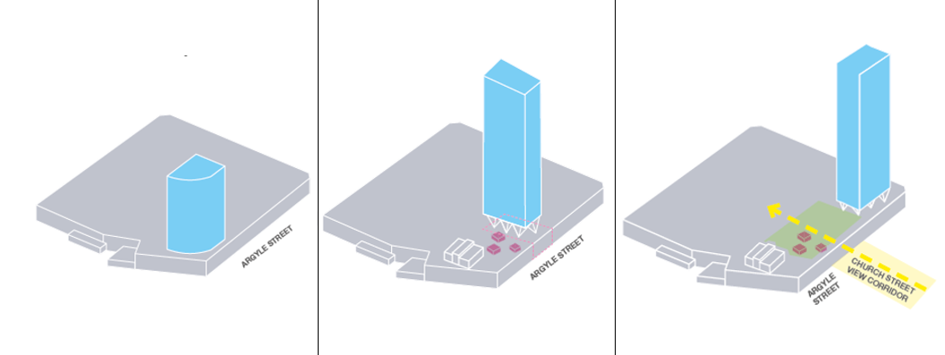
Figure 9 | Comparison between the Approved (left), EA (middle) and RtS (right) envelope

Assessment
The Department has considered the proposal, the issues raised in the submissions and the Proponent’s response in its assessment of the application. The Department considers the key issues associated with the proposal are:

- built form
- design excellence
- traffic and transport
- heritage impacts.

These issues are discussed in the following sections of this report. Other key issues relating to the application are addressed in Section 6.5.

Built Form
The proposal seeks to change the size, location and layout of the tower envelope as outlined in Section 2.

Council, GANSW and Heritage NSW initially raised concerns about the proposed changes, including the height and width of the building, the size of the building floor plates and the location of the building relative to the Church Street view corridor, heritage items and setbacks to the podium. Public submissions also raised concerns with the size and height of the building.

In response the Proponent relocated the tower to the corner of Marsden and Argyle Streets, reoriented the envelope, increased the podium setbacks and reduced the proposed maximum floor space from 112,000m² to 105,000m².

The Department has considered the height, scale and location of the proposed building envelope below.

6.1.1 Increased Height
The proposal seeks to increase the maximum building height from 120 m as approved (RL 131) to 210 m (RL 220).
The maximum height permitted on the site under the PLEP 2011 is 36 m. However, the CBD PP would allow a maximum height of RL 211, with a 15% (+31.65 m) height bonus where a design excellence is achieved through a design competition (Section 3.5 and Figure 8). This would allow a maximum permissible height of RL 240.65 m.
Council advised the proposed height should be consistent with the CBD PP. Community submissions raised concerns that the proposed building was too tall and would cause overshadowing and view impacts. Heritage NSW also raised concern the height and scale of the building would result in adverse visual impacts on nearby State heritage items and impact the significant views from Old Government House and Domain.
The Department has carefully considered the concerns raised in the submissions, however the proposed height of RL 220 m is appropriate as:
- it would be consistent with Council’s strategic planning objectives for the site and the growth of Parramatta CBD
- it would fully comply with the expected height controls under the CBD PP, subject to the Proponent’s commitments to undertake a design competition and achieve design excellence in the future DA
- it would be compatible with emerging building heights within the Parramatta CBD, including the recently constructed commercial tower (RL 261 m) at 8 Parramatta Square and the Planning Proposal approved for a maximum height of RL 250 at 2 O’Connell Street (Figure 10)
- it would not result in adverse visual impacts on nearby heritage items as it complies with the maximum height in the CBD PP and is located outside the Church Street view corridor (refer to Section 6.3)
- it would not result in unacceptable overshadowing or view loss impacts to neighbouring properties (Section 6.5).
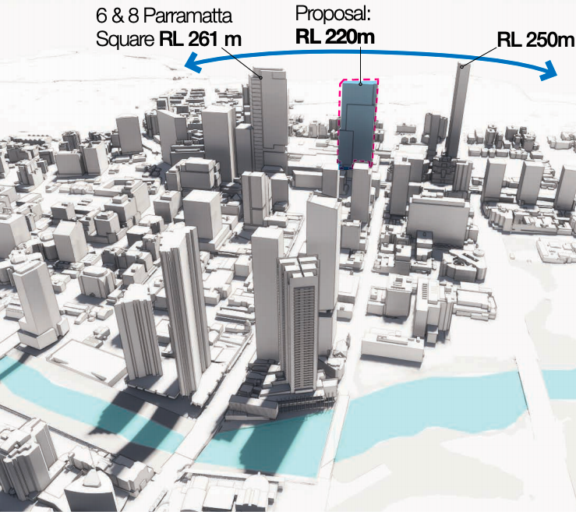
2 O’Connell Street
Figure 10 | Proposed building in the context of emerging surrounding building heights (Base Image Source: Urban Design Report, RTS)

6.1.2 Building Floor Plate and Building Depth
The Concept Approval permits a building envelope with dimensions of 45 m x 40 m, with a maximum floor plate of 1,800 m² and a maximum permitted GFA of 1,400 m² per floor.
The proposal seeks to increase the size of the building envelope to 71.5 m x 45 m, with a maximum floor plate of 2,865 m² and a maximum GFA of 2,534 m² per floor.
The Proponent contends that a large floor plate is appropriate as:
- a floorplate of at least 2,000 m² to 2,500m² GFA is essential to meet the needs of major corporate and government tenants
- the Westfield site is one of the few locations in the Parramatta CBD that is capable of successfully accommodating a large floorplate commercial tower, as other than at Parramatta Square, landownership is fragmented.
- the proposed tower location provides substantial separation distances to any existing or proposed future tower buildings
- a range of design options can be explored for mitigating bulk and scale in the final design of the tower.
Council and GANSW raised concerns about the size of the floor plate, in particular the proposed 71.5 m building envelope length. Council acknowledges the unique characteristics of the site, however it recommended the floorplate be limited in size to provide an appropriate built from in this location. Council advises the Draft DCP that is currently being developed would limit floor plates in the CBD to 2,500 m² and façade widths to 60 m in length.
GANSW also noted that existing commercial buildings in the CBD, with similar floorplates are generally much shorter, and there is only one other similar building at 8 Parramatta Square and it has smaller overall dimensions and a slightly smaller floorplate than the current proposal. GANSW therefore recommended that built from controls should specify that that the GFA not occupy more than 70% of the Maximum Planning Envelope and that building frontages should not exceed 60 m.
The Department has carefully considered the advice provided by Council and GANSW, and the justification provided by the Proponent for a large floor plate commercial building on the site.
The Department considers the provision of a large commercial floor plate is consistent with strategic planning objectives to grow a stronger and more competitive CBD with increased job opportunities and investment as it would attract more large-scale tenants to the area and contribute to the range of commercial building stock available in Parramatta (Section 3).
The Department also considers that in this case, the site is uniquely able to accommodate a large floorplate tower as the Westfield site landholding is the largest site in the Parramatta CBD and is able to provide substantial visual separation from other nearby towers.
However, the proposed tower envelope would be the largest and widest tower of this height in the Parramatta CBD. It would also be highly visible from numerous locations within and around the CBD (Figure 11) including distant views from the north and south as well as from Old Government House and The Domain. The Department also notes that while the tower is separated from nearby towers, the CBD PP would allow towers up RL 211 (or RL 240.65 with the design excellence height bonus) on other portions of the Westfield site and sites fronting Argyle Street (Figure 8) which could significantly alter the surrounding site context in the future.
Figure 2 | Potential size of the future tower in the context of other CBD buildings (Base Image Source: Visual Impact Assessment, RTS)
The Department therefore considers it critical that the future building within the envelope limit the visual bulk of the tower and closely align with Council’s emerging controls for the CBD. The Department therefore recommends:
- a maximum east-west tower length of 60 m, to ensure the building does not contribute to visual bulk when viewed from the north and south and from Old Government House and The Domain
- a minimum articulation zone of 20%, resulting in an average maximum floor plate of 80% of the envelope
- the future DA demonstrates that visual bulk as viewed from nearby heritage items and the Church Street View Corridor is minimised.
Subject to these requirements, the Department is satisfied the large building floor plates and large façade widths can be supported.

6.1.3 Relocation of tower
The proposal seeks to relocate the tower from the corner of Church and Argyle Street to the corner of Argyle and Marsden Streets (refer Figures 5 to 8).
The Proponent notes the podium will need to be demolished to provide the required structural supports for the tower and contends the relocated tower, above the Myer Department Store, would result in less disruption to the operation of the existing shopping centre.
Council and GANSW generally support the relocation of the tower as it preserves the scale and character of Church Street, south of the railway.
The Department supports the proposed tower location as:
- it is consistent with Council’s future planning controls for the CBD which would allow heights of up to RL 211 m (or RL 240.65 m subject to design excellence) on this portion of the site
- it preserves the low scale heights (maximum 36 m) along Church Street and within the Church Street view corridor by relocating the previously approved tower which encroached into these areas (Figure 8)
- it is setback at least 6 m from Argyle and Marsden Streets consistent with Council planning controls to provide visual separation from the podium and mitigate wind impacts
- it would not result in any unacceptable adverse impacts in terms of views, visual impacts, or overshadowing (Section 6.5)
- the revised tower location, and the need to demolish and re-construct part of the podium, presents an opportunity to substantially improve the podium facades and street activation on Argyle and Marsden Streets (Section 6.2).

Design Excellence
The Concept Approval requires that the future tower design be subject of a design competition and demonstrate a high standard of architectural design.
The Proponent submitted a Design Excellence Strategy (DES) which, in summary, outlines:
- a competitive design process (a single invited design competition with a minimum of 3 invited competitors selected by the Proponent in consultation with Council) would apply to the proposed tower and the podium directly below the tower
- a jury of 4 – 6 members would be appointed including half of the members nominated by Council and half nominated by the Proponent
- the Competition Brief will be prepared in accordance with the Council’s Design Excellence Competitions Brief Template, in consultation with Council, with final endorsement from GANSW prior to commencement of the design competition
- the winner of the design process will prepare the DA for the winning design.
Council advised it supports the DES however, recommended that the scope of the Design Competition also include the podium refurbishment, rooftop level (retail/dining) and public domain upgrades. In particular, Council noted the proposed street wall along Argyle and Marsden Streets should form a key part of the design and a number of objectives should be considered, with key controls included in any future design competition and agreed with Council to ensure a high-quality podium façade outcome.
GANSW reviewed the DES and recommended a number of amendments prior to commencement of the design competition. In particular, the inclusion of design quality objectives, requirements for the Competition Jury Report and inclusion of provisions for a Design Integrity Panel. GANSW also supported the inclusion of podium upgrades in the competition.
The Department considers that design excellence is critical to achieving an acceptable built form outcome on the site. The Department supports a design competition being undertaken prior to the future DA being lodged, and recommends the competition include the tower, podium beneath the tower and the public domain upgrades along the length of Argyle Street (from Marsden Street to Church Street) and Marden Street, extending at least to the north of the overhead bridge.
The Department notes that the proposal does not involve any changes to the podium outside of the tower envelope, however it is recommended the design competition address how the proposal integrates with the existing development and include conceptual future upgrades to the street wall along Argyle and Marsden Streets and any proposed upgrades to the podium roof level adjacent to the tower.
The Department therefore recommends an updated DES be developed in consultation with Parramatta Council and submitted to the Secretary for approval prior to development of the Design Competition Brief. The updated DES must:
- revise the Strategy to include objectives relating to the quality of architectural, urban design and civic amenity outcomes
- provide for a five-member Jury consistent with requirements of the Government Architect’s Design Excellence Competition Guidelines
- provide for a Competition Jury Report which identifies key attributes of the winning design that must be preserved, as well as recommendations for further design development
- provide for a rigorous Design Integrity Assessment Process including establishment of an independent Design Integrity Panel (DIP)
- include all aspects of the future development, including any changes to the podium (and any associated podium roof level upgrades), design of the street wall on Argyle and Marsden Streets and public domain improvements
- delete references to distribution of floor space and provision of an articulation zone.
The Department has also recommended an updated FEAR which sets out more detailed requirements for achieving a high standard of architectural design.
The Department concludes the DES, as amended, in conjunction with the Department’s recommended FEARs will ensure that a rigorous Design Excellence process would be applied to the future design of the building, ultimately resulting in a high-quality building that makes a significant positive contribution the building stock of Parramatta CBD.

Heritage
The site is located in the vicinity of several heritage items including St John’s Anglican Cathedral (an item of State Heritage significance 110 m to the north of the site) and Old Government House and the Domain (OGHD) (an item of State and World Heritage significance 600 m to the north-west of the site). Another seven local and state heritage items are located within the immediate vicinity of the site. It is also visible from the Church Street View Corridor, located to the north of the site.
Council, Heritage NSW and GANSW raised concerns with the visual impact of the proposed tower on St John’s Anglican Cathedral and the Church Street View Corridor, as well as OGHD.

6.3.1 Church Street and St John’s Anglican Cathedral
The Church Street view corridor is a City Centre Historic View identified by PDCP 2011. The view corridor will be formalised and protected in the CBD PP with a setback of 12m from the boundaries of Church Street. St John’s Anglican Cathedral is located within the view corridor (Figure 8 and 12).
The proposed building envelope is setback of 12m from the alignment of Church Street and therefore would be clear of the view corridor established by the CBD PP (Figures 8 and 12).
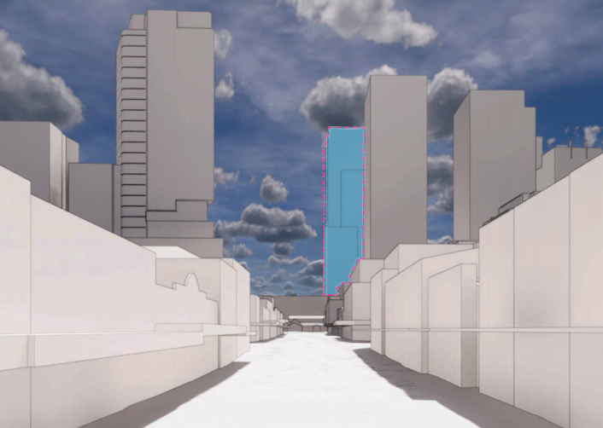
St John’s Anglican Cathedral
Church Street
Figure 3 | Proposed location of the tower in the context of The Church Street View Corridor (Base Image Source: RTS)
Council advised the tower envelope appears to be broadly consistent with the proposed CBD PP controls but advised the final alignment will need to be confirmed with accurate CAD drawings.
Heritage NSW raised concern that the proposed height and scale of the tower would dominate the skyline in the vicinity of State heritage items and impact views from OGHD. It also questioned if a north-south alignment of the building would be a better option when considering the visual impacts of the tower. In addition, it also recommended that the materials, finishes and design of the commercial tower elevations should minimise the visual dominance and reflectivity of the tower in relation to St John’s Anglican Cathedral.
GANSW advised that while the CBD PP provides a 12 m setback from the Church Street corridor, in this case an even greater setback is warranted due to the significant scale of the proposal.
The Department is satisfied that the proposed building envelope is consistent with Council’s proposed setback requirements for the Church Street view corridor. However, the Department acknowledges the concerns raised by Heritage NSW and GANSW and agrees that the tower, while not impeding the view corridor, will be highly visible from Church Street and when viewed from St John’s Anglican Cathedral.
The Department notes that the proposed building envelope does not represent the final building form and recommends the design competition and future DA explore opportunities to further improve on the visual relationship with the Church and the view corridor. As discussed in Section 6.1, the Department recommends the east-west length of the tower should not exceed 60 m. In achieving this requirement, the Department considers there is an opportunity to reduce building massing adjacent to the view corridor to minimise visual impacts and visual bulk as viewed from the Church Street view corridor and St John’s Anglican Cathedral
The Department therefore recommends FEARs be imposed to require the future DA:
- minimise visual impacts and visual bulk as viewed from the Church Street view corridor and St John’s Anglican Cathedral
- ensure materials, finishes and design of the tower elevations minimise the visual dominance and reflectivity of the tower in relation to St John’s Anglican Cathedral
- ensure detailed drawings demonstrate compliance with the 12-metre setback line from the alignment of Church Street.
Subject to these requirements, the Department is satisfied a future tower could be delivered within the proposed envelope that would not result in unacceptable visual impacts on the Church Street view corridor and St John’s Anglican Church.

6.3.2 Old Government House and the Domain
Council and Heritage NSW raised concerns with the potential visual impact of the tower on OGHD located in Parramatta Park, which is included on the National Heritage List and on UNESCO’s World Heritage List. Heritage NSW advised that if the modification is approved, conditions should be included to ensure tower materials, finishes and design minimise the visual dominance and reflectivity of the tower in relation to OGHD and external signage should be designed to minimise visibility from OGHD.
The Proponent’s Heritage Impact Assessment (HIA) considered the proposal against the guidelines provided within the 2012 report prepared by Planisphere on Development in Parramatta City and the Impact on Old Government House and Domain’s World and National Heritage Values (the Planisphere Report).
The HIA notes the modified envelope is located within the sensitive view zone from Old Government House classified in the Planisphere Report as a ‘High significance view’. However, the HIA concludes the proposal would not cause any significant visual impacts on the composition of views from OGHD, noting it will be visible in the context of other similar building forms forming part of the city skyline of buildings present and proposed in the CBD (Figure 13 and 14).
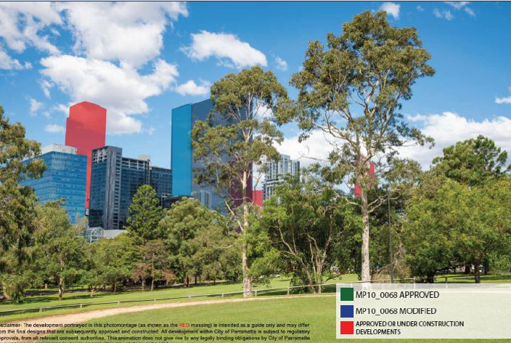
Figure 4 | View from in front of Old Government House (Base Image Source: HIA) (Note: image also includes the initially proposed envelope (in the EA) in light blue)
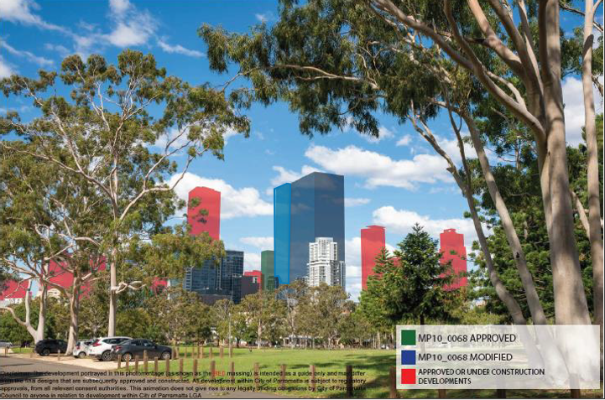
Figure 14 | View from the entry road to Old Government House (Base Image Source: HIA) (Note: image also includes initially proposed envelope (within the EA) in light blue)

The Department has considered the concerns raised by Heritage NSW and Council and the guidance provided within the Planisphere report. The Department considers the visual impacts of the proposal from OGHD are acceptable as:
- the proposal is consistent with the Planisphere development guidelines as it:
- locates a tall tower within the city central precinct reducing its prominence in the skyline
- will provide a well-proportioned visually interesting design subject to FEARs limiting the tower length and volumetric fill to ensure a suitably articulated and elegant final building form which can achieve design excellence
- aligns with the street grid reinforcing the formal layout of the Georgian Town plan
- the future building, located approximately 600 m from Old Government House, would be read as part of the city skyline which makes up the background of the views
- the proposed new CBD PP controls have been carefully developed by Council having regard to the impacts to the heritage values of OGHD and would allow for several other similar height buildings in the vicinity of the proposed building. The proposed building would present as similar in height and would be subsumed into views of the emerging city skyline over time.
- the Department recommended FEARs (refer also to Section 6.1) will ensure the future built from within the building envelope including
  - a maximum east-west tower length of 60 m, to ensure the building does not contribute to visual bulk when viewed from OGHD
  - a minimum articulation zone of 20%, to ensure a satisfactory level of articulation of building massing within the approved envelope
  - the future DA is to demonstrate that materials, finishes and design of the tower minimise the visual dominance and reflectivity as viewed from OGHD
  - the future DA is to demonstrate that all proposed signage is designed and located to minimise visibility for OGHD.
On this basis, the Department is satisfied the proposal is consistent with the guidance within the Planisphere report and would not result in unacceptable visual or heritage impacts to OGHD.

Parking, Traffic and Transport

6.3.1 Parking
The Concept Approval allows for an additional 562 parking spaces on the site (100 spaces for the commercial office tower and 462 additional spaces for the retail use). The proposal does not alter the 100 spaces for the commercial tower or the additional approved retail spaces, however due to the siting of the envelope would result in the loss of 20 existing retail spaces on the shopping entre roof.
Loss of parking was a key concern raised in the public submissions, noting that the earlier scheme as outlined in the Proponent’s EA reduced retail parking by 273 spaces (from 462 to 189).
The Department considers that the proposed level of car parking is acceptable, and responds to the issues raised in submissions as:
- the proposal complies with the car parking requirements of PLEP 2011, which sets maximum, rather than minimum parking rates for retail and commercial uses in the CBD and seeks to reduce reliance on private motor vehicles
- the proposed reduction in 20 retail car spaces is minor in the context of the approximate 5,000 parking spaces that would be delivered on the site, and the Transport Assessment submitted with the proposal demonstrates that the proposal would provide sufficient retail parking to meet expected demands
- the 100 car parking spaces for the commercial use remains appropriate as:
  - the site is ideally located to restrict parking and encourage use of public transport, being immediately adjacent to Parramatta Railway Station and bus interchange
  - it will ensure the proposal does not lead to increased traffic impacts in the area, noting that many surrounding streets and intersections are already congested.

6.3.2 Traffic Impacts and Traffic Infrastructure
Traffic Generation
The Proponent provided a Traffic Management and Accessibility Plan (TMAP) which concludes:
- the proposal would not result in any increased traffic impacts on the surrounding road network, compared to the approved development
- service vehicle movements associated with the commercial tower (10 to 20 vehicles per day) would not result in any material impact on the operation of the surrounding road network.
Council raised concerns that the TMAP did not assess intersection performance and traffic generation impacts based on updated / current modelling. TfNSW recommended that the future DA for the tower should include a Loading and Servicing Management Plan based on independent surveys to demonstrate that future loading and servicing facilities within the site could adequately accommodated service vehicle movements and demand.
The Department accepts the findings of the TMAP and is satisfied the proposal would not result in any material impacts to the overall traffic network compared to the Concept Approval, as it reduces the overall parking provision by 20 spaces. The Department is satisfied traffic impacts can be appropriately assessed and mitigated as part of the future DA, and recommends FEARs requiring a detailed traffic assessment and a loading and servicing management plan to be submitted as part of the future DA.
Traffic Infrastructure Upgrades
The Stage 1 Project Approval requires traffic infrastructure upgrades, including upgrades to nearby intersections on the Great Western Highway and Church Street.
Council raised concerns that the proposal did not address traffic infrastructure upgrades required under the original Project Approval. It suggested the Proponent should fund upgrades to the intersection of Marsden Street and Campbell Street not previously proposed. TfNSW requested that the traffic infrastructure upgrades required by the Stage 1 Project Approval be delivered.
In response, the Proponent advised no changes are sought to the Project Approval and no additional infrastructure upgrades are proposed as part of this modification, however the need for infrastructure / intersection upgrades could be addressed as part of a future DA for the office tower.
The Department has considered the advice provided by Council and TfNSW. However, the Department notes that the traffic impacts of the Concept Plan relate predominantly to the expansion of the retail floorspace and parking associated with Stage 1, rather than the proposed commercial tower. As outlined above, the proposal does not seek to alter the approved 100 car parking spaces for the commercial tower and seeks to reduce retail parking by 20 spaces and would not result in any additional traffic impacts, compared to the Concept Approval. As such the Department considers there is no basis to require the Stage 1 roadworks to be delivered as part of the future DA for the commercial tower.
Notwithstanding, the relocated commercial tower and associated servicing may have some impact for local traffic movements at other intersections on Marsden or Argyle Streets. The Department therefore recommends a FEAR that the future DA for the commercial tower consider the traffic generation caused by the 100 parking spaces and service vehicles, and where necessary, make provision for funding or delivery of any infrastructure upgrades required to offset the impacts of the development.
Construction Traffic Impacts
TfNSW recommended a draft construction traffic and pedestrian management plan be required as part of the future DA. The Department notes existing FEAR 11 already addresses this requirement and considers traffic and pedestrian management can be considered as part of the future DA.

6.3.3 Transport and Pedestrian Movement
The proposal will generate increased demand for public transport and other modes of travel, as well as increased pedestrian movements along Argyle Street.
Pedestrians
The TMAP concludes that the 5 metre wide footpath along Argyle Street (including the colonnade width within the site boundary) provides sufficient capacity to accommodate the existing and expected additional pedestrian flows generated by the development, without creating congestion for pedestrian traffic or any impacts to the existing transport facilities or bus operations on Argyle Street.
GANSW, Council and TfNSW raised concerns that the initial plans indicated outdoor dining along Argyle Street, which would reduce the effective width of the footpath and could result in impact for pedestrian movements and bus stops. However, following removal of all outdoor dining in the RTS, no further concerns were raised in relation to the capacity of the footpath to accommodate pedestrian movements.
The Department is satisfied the additional pedestrian flows created by the development could be safely accommodated on the site and surrounding footpaths.
Public Transport
The TMAP concludes that there is sufficient capacity in the exiting bus and train services that operate out of the Parramatta CBD to accommodate the demand generated by the development.
TfNSW and Council recommended that a draft Green Travel Plan be prepared to encourage use of alternative modes of transport.
The Department considers the site has excellent access to existing train and bus services and planned future transport the Parramatta light rail and Sydney West metro projects currently under construction. The Department supports measures to increase use of non-car modes of travel and recommends a FEAR requiring the future DA include a Draft Green Travel Plan.
Cyclists
Council requested that consideration be given to coordinating access with the Parramatta Bike Plan and that the future DA demonstrate safe cyclist access and end of trip facilities. The Department is satisfied the proposal does not give rise to specific additional concerns for cyclist safety, access or facilities and these matters would be considered as part of the future DA.

Other issues
The Department’s consideration of other issues is provided in Table 7.
Table 7 | Summary of key issues
Issue | Findings | Recommendation
Public Domain Upgrades | - The Proponent submitted a landscape and public domain plan which proposes landscape and public domain improvements along Argyle and Marsden Streets (including new street tree planting, street furniture, pavement upgrades and public art) as well improvements to the pedestrian crossing arrangements at Church and Argyle Street.  - Council recommends the works should be extended further south on Marsden Street, and identified a number of other public domain upgrades that require further consideration. Council also recommended the public domain upgrades be a component of the Design Competition.  - In response, the Proponent confirmed that public domain improvements can be resolved as part of the future DA, with plans to be prepared in consultation with Council.  - The Department notes the proposal will result in a substantial increase in foot traffic (discussed in Section 6.4) and agrees with Council that the future DA should include public domain improvements commensurate with this increase. The Department therefore recommends:  - the public domain is upgraded along the entire length of Argyle Street up to Church Street to improve access and amenity for pedestrians travelling to and from the station  - public domain works are extended south along Marsden Street to at least the second vehicle crossing  - public domain works are included as part of the proposal within the Design Competition brief |  | The Department recommends Condition B1 and FEAR 6 be updated to require public domain improvements to be considered as a component of the Design Competition and included in the future DA
Views | - One public submission raised concern that the proposal would result in loss of views for apartments in Campbell Street.  - The Proponent considers view impacts to Campbell Street properties are modest, noting northern views are of the CBD Skyline of Parramatta and the proposed office tower will be subsumed into this skyline view.  - The Department notes existing residential buildings on Campbell Street are generally 8 to 10 storeys in height and subject to a height control of 28 metres. Some upper-level apartments currently enjoy views over the top of the site. These views would be obscured by the Tower, but also by the approved Stage 1 development which will increase the height of the shopping centre to the equivalent of 9 – 10 storeys.  - The Department has considered the proposal against the view sharing principles established by Tenacity Consulting v Warringah Council [2004] NSWLEC 140 and considers view impacts would be acceptable and the proposal is reasonable, noting that:  - existing views from the north facing windows and balconies of upper-level apartments on Campbell Street are directly over the top of the site are generally partial and skyline views only with no identified iconic views or whole district views  - the proposed tower would not result in any material additional loss of district views from these locations, compared to the Stage 1 approval, which would obscure almost all views over the top of the site from most residential buildings on Campbell Street  - as the Parramatta City Centre develops, the proposed tower would be subsumed into the views of the skyline and in this context, impacts to outlook would be modest  - the existing planning controls (36 m) and the proposed planning controls (up to RL 211 m plus permitted bonuses) allow for built forms that exceed the height of buildings on Campbell Street and as such there can be no reasonable expectation of view retention over the top of the site  - The Department therefore concludes the proposal is reasonable as it complies with the emerging planning controls and would not result in any material additional impacts than the Stage 1 approval. |  | No changes to conditions recommended
Overshadowing | - Public submissions raised concern that the proposal would result in overshadowing of the surrounding area. Council also initially raised a concern that the proposal would overshadow Ollie Webb Reserve, an area of public open space located approximately 500 m to the south-west of the proposed tower.  - The RtS relocated and revised the orientation of the tower to minimise shadow impacts. Shadow diagrams demonstrate that the majority of shadows from the tower would fall over the remainder of the Westfield site, and while mid-winter shadows would extend to the residential area to the south of the site, the shadows move quickly across north facing facades of residential buildings to the south (generally affecting buildings for between 30 minutes and 1 hour), and all dwellings would retain in excess of 2 hours of solar access at mid-winter, consistent with expectations under the ADG.  - The amended scheme also demonstrates that while there would be some minor overshadowing of Ollie-Webb reserve at 9.00 am mid-winter, the proposal would not impact the park after 10.00 am, which is consistent with Council planning controls.  - The Department is therefore satisfied the proposal would not result in any unacceptable overshadowing impacts. |  | No changes to conditions recommended
Number of Floors / Floor Height | - The Concept Approval does not approve a specific number of storeys within the approved building envelope.  - The proposal initially sought to increase the number of permitted floors from 25 to 42 resulting in a floor to floor height of 4.2m, but the RTS sought to further increase the number of floors to 47, resulting in a reduction in floor to floor heights to 3.75 m to accommodate the additional 6 storeys and the total maximum GFA of 105,000 m².  - GANSW raised concerns with the proposed floor to floor heights would be sub-optimal to achieve a high level of internal amenity for the proposed large floor plate.  - The Department considers that there is insufficient information at the Concept Plan stage to determine the appropriate floor to floor height, having regard to whether the design achieves adequate internal amenity, including access to light and solar access, energy efficiency and sustainability outcomes and other design excellence considerations.  - The Department therefore considers the floor to floor heights, and therefore the ultimate number of storeys that can be achieved on the site should be matters for consideration at the future DA stage, and acknowledges this may affect whether the future DA can achieve all the of GFA sought.  - The Department recommends a term of approval clarifying that the number of storeys are not approved as part of the Concept Plan, and this will be determined as part the future DA. It also recommends a note is added to clarify that this may affect the total amount of GFA that can be achieved on the site. |  | The Department recommends new condition A8 in relation to floor to floor heights / number of storeys and a clarification in condition A5 that approved GFA is a maximum figure and compliance with other conditions may result in the maximum not being achieved.
Provision of mid-rise levels | - The modifications to the tower envelope as described in the RtS report advise the envelope includes 4 mid-rise tower / transfer service levels (at levels 18, 19, 31, and 32).  - The Department notes the provision of mid-rise levels are not depicted in any envelope plans and considers the location of any such levels is beyond the scope of the Concept Plan and is a matter for consideration as part of the design competition and detailed DA.  - The Department therefore recommends a term of approval clarifying that the location of mid-rise levels is not approved as part of the Concept Plan. |  | The Department recommends new condition A9 in relation to mid-rise transfer/ service levels
Sustainability | - The Concept Approval requires the commercial tower achieve a minimum 5 Star Green Star rating.  - The Proponent provided an ESD report demonstrating a 5 Star Green Star rating can be achieved.  - GANSW initially raised a concern that the larger floorplate would result in sustainability impacts with large parts of each floor being located more than 12 metres from a window. GANSW also recommended that the building be designed to a 6 Star Green Star standard, rather than 5 stars as proposed.  - Council recommended incorporation of green roofs or similar strategies to reduce urban heat island effects on the site.  - The Department has considered the advice provided by GANSW and Council, and on balance considers the Proponent’s commitments to ESD are acceptable as:  - the proposal will achieve a 5 Star Green Star rating, consistent with the Concept Approval and Council’s planning controls:  - the Proponent has demonstrated that a future building within the envelope could achieve 80% of the floor area within 12 m of a window  - the detailed ESD measures and initiatives can be further explored in the future DA, including the provision of green roofs or the like  - The Department recommends a FEAR that 80% of the usable office GFA is located within 12 m of a window.  - The Department is therefore satisfied the future DA will be capable of achieving appropriate ESD outcomes consistent with the intentions of the original approval. |  | The Department recommends FEAR 5 is amended to ensure at least 80% of the floor area is within 12m of a window and to update references to the ESD report.
Aviation | - Sydney Metro Airports advised the future DA will require formal assessment by Sydney Metro Airports as the proposed tower envelope exceeds 156m AHD.  - The proposed envelope is consistent with the heights envisaged by the CBD PP and other buildings in the area and therefore the envelope height is unlikely to result in significant concerns in relation to aircraft safety.  - The Department notes that Sydney Metro Airport approval is a separate approval process and recommends a new FEAR requiring the future DA demonstrate it meets the requirements of Bankstown Airport. |  | The Department recommends a new FEAR 16 requiring the future DA to demonstrate it meets the requirements Bankstown Airport
Wind Impacts | - Council initially raised a concern that the proposed tower was setback only 3m from the podium / Street wall along Argyle Street, resulting in potential wind down draft effects on the footpath.  - In response, the proposal now provides a 6-metre setback to the street and the podium levels. The proponent also provided an updated preliminary wind impact assessment which indicates a future building on the site can be designed to maintain acceptable wind conditions at the pedestrian level and the Level 6 terrace, subject to incorporation of screening and plantings.  - The Department is satisfied that proposed 6 m setback addresses Council’s initial concerns about down draft wind effects on the public domain. The Department concludes that wind impacts and pedestrian comfort can be addressed as part of the future design though the design competition and future DA. |  | No changes to conditions recommended
Developer Contributions | - The Concept Approval requires Developer Contributions to be paid to Council in accordance with the requirements of the Contributions Plan current at the time of approval.  - No changes are proposed to this requirement and Council has not raised any concerns in relation to contributions.  - The modification initially included a Statement of Commitment that in addition to the required contributions, the Applicant would enter into a VPA to provide for a $500,000 cash contribution towards public domain improvements for Church Street, however the offer was subsequently withdrawn by the Proponent.  - The Department considers the existing condition ensures appropriate contributions would be paid to Council. |  | No changes to conditions recommended

Evaluation
The Department has assessed the modification application and supporting information as refined in the Proponent’s RtS in accordance with the relevant requirements of the EP&A Act, advice from the Government agencies and comments made by Council. The Department has thoroughly assessed all the environmental issues associated with the proposal.
The Department’s assessment concludes that the proposal is acceptable for the following reasons:
- it is consistent with the Region Plan, Central City district plan and other strategic planning policies which all aim to promote the growth of the Parramatta CBD as a key commercial and civic centre for Sydney
- the proposed building envelope height and tower location fully complies with the Central Business District Planning Proposal ( CBD PP) and is consistent with the evolving character of Parramatta including the recently constructed commercial tower (RL 261 m) at 8 Parramatta Square and the Planning Proposal approved for a maximum height of RL 250 at 2 O’Connell Street
- the provision of a large commercial floor plate will increase job opportunities and investment in Parramatta CBD as it would attract more large-scale tenants to the area, contribute to the range of commercial building stock available in the CBD and comply with the draft Parramatta CBD planning controls
- it will improve streetscape activation and facilitate the upgrade of the public domain along Argyle and Marden Streets
- it would not result in any unacceptable heritage impacts as the building envelope is setback 12 m from the alignment of Church Street, will have a maximum east-west length of 60 metres consistent with the draft Parramatta CBD planning controls and FEARs are recommended to ensure the future massing, design and materials of the building minimise visual impacts to Old Government House and the Domain (OGHD), St John’s Anglican Cathedral and the Church Street view Corridor
- it would not result in any adverse traffic impacts as the site has excellent access to existing and planned public transport and proposes 20 less car parking spaces than originally approved and loading and servicing requirements, impacts and any mitigation measures will be assessed in the future DA
- it would not result in unreasonable view loss, overshadowing, wind or other amenity impacts to neighbouring properties and the public domain
- the future DA would provide up to 700 construction and 2,200 operational jobs
- the Department recommends a suite of conditions to ensure:
  - a design competition is held prior to the submission of the future DA and a Design Integrity Panel is established to ensure the future building achieves design excellence
  - the maximum east-west building length does not exceed 60 m and a minimum articulation zone of 20%
  - the materials, finishes, design and signage minimise visual impact and reflectivity impacts when viewed from OGHD
  - the future DA assesses, manages and mitigates potential impacts associated with traffic, transport, servicing, aviation safety, Sydney Trains requirements, contamination and environmental performance.
Consequently, the Department concludes proposal is in the public interest and recommends that the proposal be approved, subject to the recommended changes to the conditions of approval (Appendix B).

Recommendation
It is recommended that the Executive Director, Key Sites and Regional Assessments, as delegate of the Minister for Planning and Public Spaces:
- considers the findings and recommendations of this report;
- determines that the modification application (MP10_0068 MOD 1) falls within the scope of section 75W of the EP&A Act;
- accepts and adopts all the findings and recommendations in this report as the reasons for approving the modification application;
- modifies the Concept Approval MP10_0068; and
- signs the attached Modification of Approval (Appendix B).

Recommended by: Recommended by: 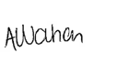 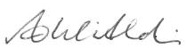
Amy Watson Anthony Witherdin
Team Leader Director
Key Sites Assessments Key Sites Assessments

Determination
The recommendation is Adopted by:

Anthea Sargeant
Executive Director
Key Sites and Regional Assessments
as delegate of the Minister for Planning and Public Spaces

Appendices

Appendix A – Relevant Supporting Information
The following supporting documents and supporting information to this assessment report can be found on the Major Project’s website as follows:
- Modification Report and Response to Submissions
http://www.majorprojects.planning.nsw.gov.au/index.pl?action=view_job&job_id=7989

- Submissions
http://www.majorprojects.planning.nsw.gov.au/index.pl?action=view_job&job_id=7989
- Associated modifications (MP 10_0068)

Appendix B – Modification Report
http://www.majorprojects.planning.nsw.gov.au/index.pl?action=view_job&job_id=7989

Appendix C – Consideration of Environmental Planning Instruments
State Environmental Planning Policy No. 55 - Remediation of Land
SEPP 55 aims to ensure that potential contamination issues are considered in the determination of a development application.
The RtS included a Desktop Study for contamination (DSC) Report which identified the following potential areas of environmental concern (AEC) at the site:
- the placement of contaminated fill to form and level the site
- demolition of buildings containing potentially hazardous material
- oil leaks from onsite grease traps and substation
- previous commercial uses on site
As the site is currently occupied by the existing shopping centre, the DSC did not undertake soil and ground water testing and a conclusive assessment of land contamination status, cannot therefore be made at this stage. The DSC Report concluded that the site has generally low risk for contamination and that previous uses of the site should be further investigated, and some intrusive investigation should be undertaken to assess contamination prior to site development.
The Department considers the findings and recommendations of the DSC are acceptable and recommends a FEAR requiring future DA(s) include a Detailed Site Investigation (DESI), contamination assessment and Remedial Action Plan (as necessary) to demonstrate that site can be made suitable for its intended use.
Draft State Environmental Planning Policy (Remediation of Land)
The Department is reviewing all State Environmental Planning Policies to ensure they remain effective and relevant and SEPP 55 has been reviewed as part of that program. The Department has published the draft Remediation of Land State Environmental Planning Policy (Remediation SEPP), which was exhibited until April 2018.
Once adopted, the Remediation SEPP will retain elements of SEPP 55, and add the following provisions to establish a modern approach to the management of contaminated land:
- require all remediation work that is to be carried out without development consent, to be reviewed and certified by a certified contaminated land consultant
- categorise remediation work based on the scale, risk and complexity of the work
- require environmental management plans relating to post-remediation management or ongoing management on-site to be provided to Council.
The new SEPP will not include any strategic planning objectives or provisions. Strategic planning matters will instead be dealt with through a direction under section 117 of the EP&A Act.
The Department considers the development is consistent with the draft Remediation SEPP subject to the recommended conditions discussed above.

